Good News reaches even Russians!
God’s Love penetraits through any covid19 restrictions!

ArtWord Festival: This year we adjusted our ways of sharing the Gospel: we rented Kursk city largest park for the art concert. We invited both Christian and unchurched talented God seeking people to perform their best music, songs and other art elements. It brought several hundreds of their friends! Our concert become the biggest events in this park ever! (all food court was sold out ). It also was widely shared through their various social networks. God blessed us to share the Gospel!
Praise the Lord!
Kayak trips: This summer we planned to do two kayak trips, but we had to do four! Knowing that we are Christians, many young people (and their parents, sometimes ), begged Valery to let them go with his team.
Quiet evenings around the fire created the best opportunities to talk about God, about meaning of life and spiritual values. God touched many hearts,
Praise the Lord!
.
Gypsy Ministry is “on the ball” here in Russia! Andrey, pastor of Kursk Gypsy church “Davlesku Lav” had many new baptisms. Their team is traveling all over the central Russia: Voronezh, Shahty, Tula, several towns in in Kursk, Voronezh and Ryazan area.
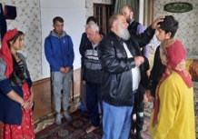
Pastor Andrey and my brother Vitaly lead a big Gypsy evangelistic event, organized by my middle brother Oleg at his farm in Ryazan area .
Praise the Lord!
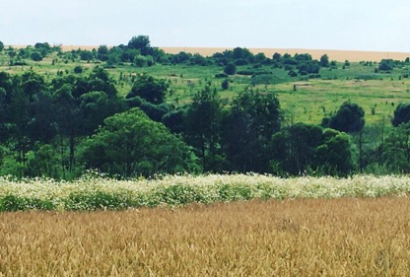
Summer camps: This summer we managed to rent the “Island of Salvation” camp ground on the river. (We used this island freely before). Four of our Kursk churches conducted their shifts there. About 200 kids, from our churches and their friends from unchurched families had opportunities to dip themselves into the Christian atmosphere, learn, listen, play, participate and come to Christ as their Savior.
Praise the Lord!

Good news on our Summer camp land: After much red tape we got our land code changed from the agricultural use into the recreational use! Now we can legally use it for the recreational purposes, such as summer camps, family rest events etc.
Praise the Lord!
More good news: our land was added to the village land, which, after some more paper work, will allow us to build heavy buildings, such as resort, sport and concert hall! This makes a great foundation for further development and various ministries!
Praise the Lord and continue to pray for it!

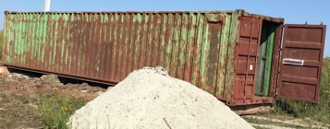
We use every cent wisely; many local believers help with this important project as much as they can, and more.
But we really need your hand to be able to build this ground for God’s ministries!
Next year we plan to bring the access road, install the 40 fts sea container (we already purchased it recently), water well etc. We dream to rent 5-8 more acres between our land and river so as to build there our play/sport ground and simple pond for swimming.
Christmas for Orphans: These days we are training church youth teams to do the Christmas pays and concerts in the seven+ orphanages we visited so far. Covid19 restrictions are still in place here. But we go by faith, hoping that the Lords will open the door to share the Gospel with 350-550 orphans this December and January. So far, we have only 1k designated for the Christmas gifts for orphans.
Would you join us in this significant ministry? We really need your help and prayer support!

From the bottoms of our hearts we thank you and everyone who
prayed for and supported God’s saving work in Kursk area!
NOTE! NOTE! NOTE! Now Kursk Ministry news will be coming to you fresh via Facebook.
Please sign here and invite these who want to see what God is doing in Russia to sign up: https://www.facebook.com/groups/502365494013470/
May God bless you abundantly and lead you in everything you do!
With Christian love,
Igor Petrov and Kursk ministry team. https://kurskministries.org
P.S. If your heart is touched by God’s ministry in Russia, please send a check/support to:
Christ Centered Homes P. O. Box 777 Atlanta, TX 75551
Christ Centered Homes is the non-profit organization, which oversees this ministry and serves as the advocate for Kursk Ministries. Christ Centered Homes will send you a statement for your taxes.
Our various ministries would really be much stronger if you would give them your hand!

P.S. 2.
Our ArtWord Festival was near this lake.

