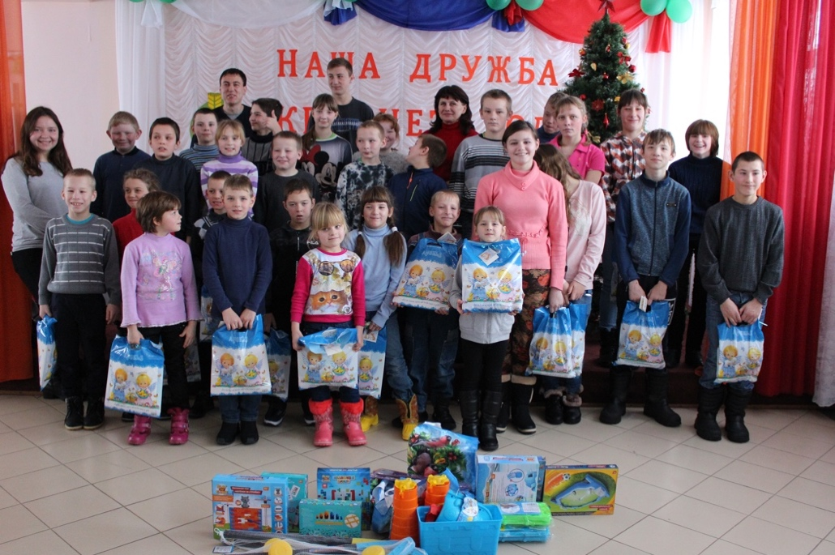
Christmas is coming! It will be Merry Christmas!
Virus doesn’t have any good crown, Jesus does!
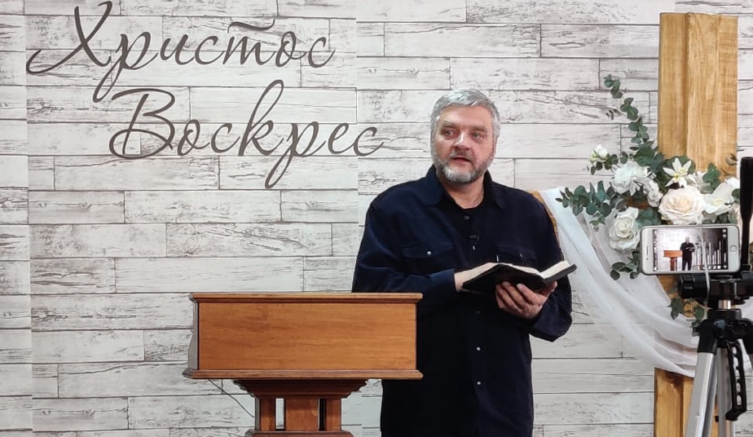
This year was over full of great events in spite of virus, sorry for not sharing about them earlier. January of 2020 held us busy bringing Christmas presentations to seven orphanages. Our youth teams did not come to the orphanages with empty hands, thank you for providing Christian books and gifts for over 670 orphans!
Now we are quietly asking orphanages’ administrations whether they want our Christmas youth teams to visit this time, and they seem to keep some doors open. Please pray and support!

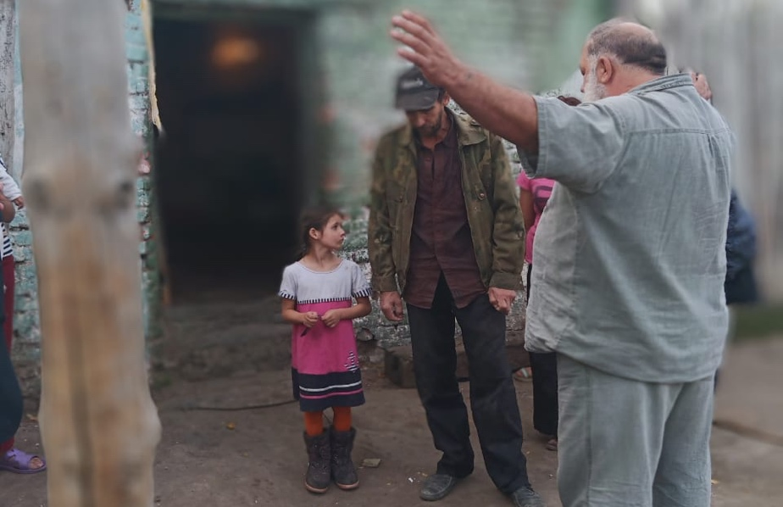
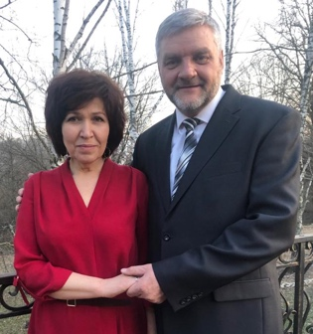
On march 28, right before government registration offices were shut down due to the covid19 quarantine, right before Moscow was about to be locked down, Nadezhda and I got married! Pastor Andrey performed our wedding at our dacha, since all the churches weren’t allowed to do big gatherings and all the restaurants were locked. Nadezhda is a gifted personal evangelist, home group leader and Christian conferences’ administrator. She is a prayer warrior and health warrior, as well as financial consultant for many. Many times, during the last year, God showed us His will to bring us together and now we see manifold blessings in our marriage from Him! She moved into Kursk from Moscow and we support each other in many ways. It was a very happy lockdown/honeymoon for us! Praise the Lord!

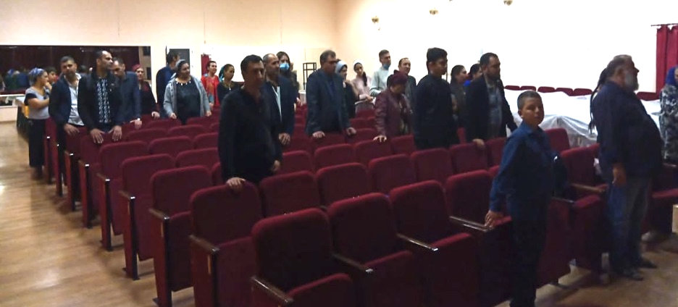
By the middle of April our church set up our online services. We did not do everything perfect, we used simple equipment, but we got up to 4000 viewers! These, who would never come to our church, were able to watch our services! https://youtu.be/z5ZbQoDErh8 Praise the Lord!

Another good news: we see up to 140000 increase in number of our TVSeminary.org courses’ views during the pandemic! God can turn bad into good! Praise the Lord! https://www.youtube.com/channel/UCowpGfhT5VqaN6X8eu1AtYw

Russian economy is going down, number of stores and businesses are getting closed. Many people are suffering. During the lockdown, Nadezhda and I decided to buy wheat, oats, oil, sugar and chickens in a big bags and take it to our brothers and sisters in Kursk Gypsy church Davlesku Lav. Spring is the hardest time for them: nobody hires them, any iron scrap they collected was under the snow all winter, some families even have eaten the potatoes designated for planting. As you probably remember, I led a seminar on their conference during the fall of 2019. So, they accepted our family “food car trips” with open hearts! This winter will be even worse for such needy people, so, please pray and share some support for their food.

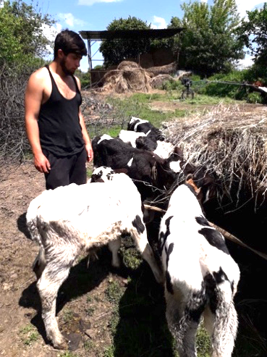
By the way, in spite of a very bad conditions, Kursk Gypsy Evangelical Church “Davlesku Lav” is very active in evangelism! This year they did four evangelistic trips to share the Gospel with Gypsies within 150-350 miles! Their van and car are about to fall apart, but we help to fix them so far. Please pray for their needs and praise the Lord!

God knows these who helped our Gypsies to start calf rising business! We are so thankful to them! We see some other business opportunities suitable for Gypsies here. If someone wants to help their families to develop small businesses to provide ongoing income for their families and their great evangelism, let us know .
You should hear how they sing!!! We, Russians and some white Americans, sound like a “sleepy flies” (Russian idiom) comparing to them! No wander Kursk officials invite Kursk Gypsy Church team to sing on their city concerts. They sing their national music and sing about salvation in God using this opportunity! Praise the Lord!
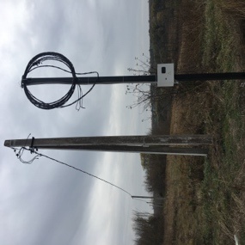
Camp land project is developing slowly. We brocked 6 hectars/13acres lot into two lots legally and started a complicated process of changing land use code from agricultural into recreational. Laws related to this will change since 2021, so, we are waiting till January 2021. Good news: we have verbal agreement of local officials to allow it! Please pray that this very important process would go well.
Good news: finally, government brought 300 yards electricity line to the edge of camp land! We did not pay for it! Praise the Lord!

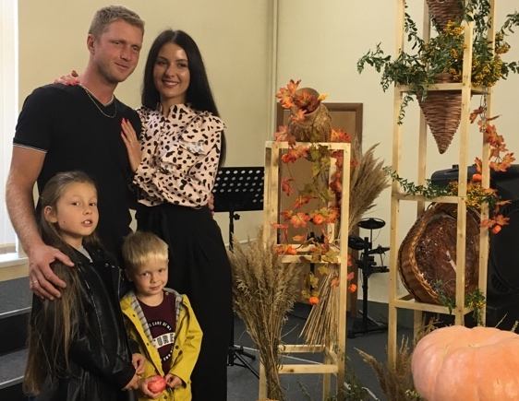
Petrov family news:
Igor and Nadezhda: This November I contracted covid19 in not hard form. I stayed home because all the hospitals were overfull. Nadezhda and my sons took very good care of me. I am fine now, no sense of smell yet, though. Well, no smell may be helpful for an oldy sometimes.
Several other ministers and Kursk area church members got sick also, many got well by now. Everybody is alive so far, praise the Lord!
Victor and Kristina are doing well; their kids Alice and Bogdan are great blessing. Here they are after the Thanksgiving service in our NT church:

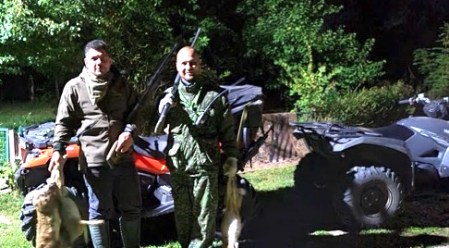
Andy keeps himself busy with our nursery, outdoor camping and hunting. 30 years old big man wants to marry… some day… but is afraid to marry after he have seen many unhappy marriages
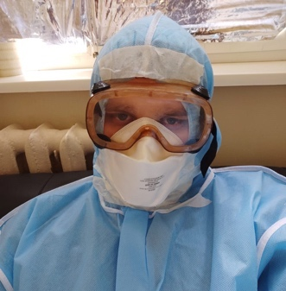
He has really loving and carrying heart for people in need, drunks and homeless. He saves people in car accidents, gets cars from the mud using his 2004 Toyota Helix truck. He took a very good care for me arranging for CT screening, finding the right medicine, which is in a big shortage here now. Please pray that he would be closer to God. And tell God that I want to see Andy’s children

Cornil has become one of the most important medical engineers in a big Moscow company. He is installing and fixing extremely needed Computer Tomographs all over the Russia from far East to West. He is really on the front line fighting covid19 these days. I am honored to have such son! Please pray for him!

From the bottoms of our hearts we thank you and everyone who
prayed for and supported God’s saving work in Kursk area!
NOTE! NOTE! NOTE! Now Kursk Ministry news will be coming to you fresh via Facebook.
Please sign here and invite these who want to see what God is doing in Russia to sign up: https://www.facebook.com/groups/502365494013470/
May God bless you abundantly and lead you in all you do!
With Christian love,
Igor Petrov and Kursk ministry team. https://kurskministries.org
P.S. If your heart is touched by God’s ministry in Russia, please send a check to:
Christ Centered Homes P. O. Box 777 Atlanta, TX 75551
Christ Centered Homes is the non-profit organization, which oversees this ministry and serves as the advocate for Kursk Ministries. Christ Centered Homes will send you a statement for your taxes.
Our various ministries would really be happy if you would give them their hand!

