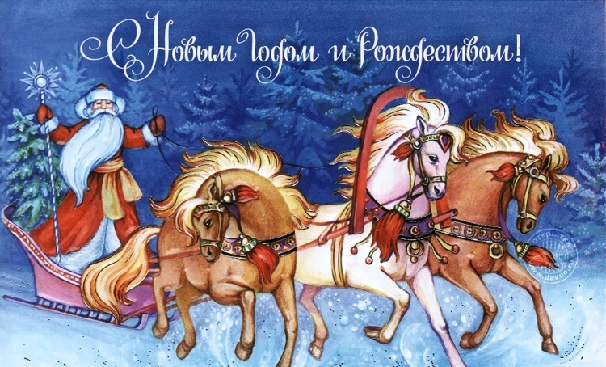
Merry Christmas Dear Friends!

This year was hard but full of blessings from the Lord and we thank Him and His people for:
TVSeminary
- Lord’s protection for us and many evangelicals in Russia in spite of many challenges, pressures and uneasy situations: several evangelical schools in Russia were closed in 2019, at least three church buildings were demolished as “not complying with the building code requirements”.
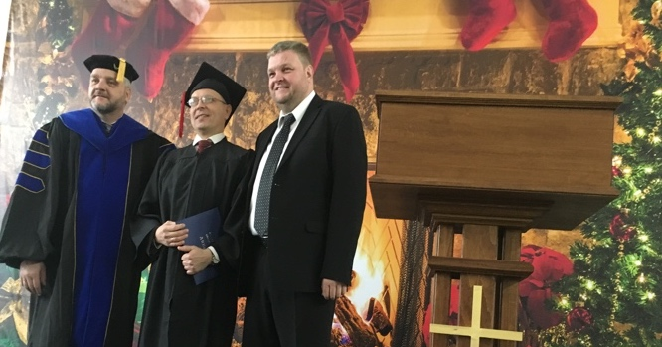
- Over 4000 students are enrolled in our online learning school https://en.tvseminary.org
- Over 130000 views within last 3 years of our course videos via YouTube, Vimeo, FB, and other means. Some of our 10-20 min. pieces if course videos become very popular and got tens of thousands views and much discussions.
- Growing number of high-quality graduates, who serve in their churches as local denominational leaders, pastors, teachers, evangelists etc.
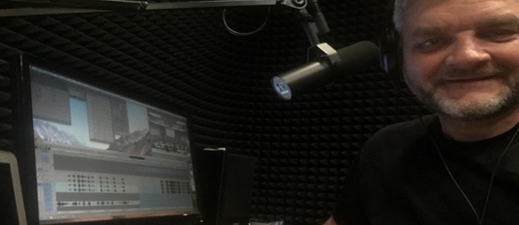
- Over ten video courses were translated, produced and added to our educational platform tvseminary.org and to our Youtube https://www.youtube.com/channel/UC7BYAAd1zQqupovkjaz6p1w
- I am so glad that I finished dubbing Theology III video course! Here is what I sing while being locked on the soundproof room
“In the dark-dark room
With the comps and mic
Spending hours, hours, hours
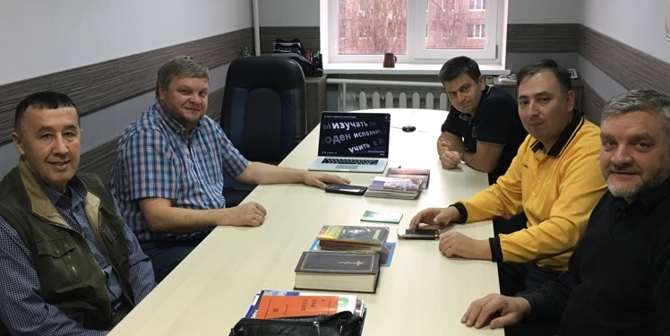
Dubbing courses!”
This year our Uzbek co-workers translated two video courses into Uzbek language.
This week our Uzbek brother (left) brought here gifted Tadjik Christian brother (in yellow). We trained him to translate and dub our course into Tadjik language! Praise the Lord! This ministry is spreading like a fire!
Church
We praise the Lord for our New Testament Church:
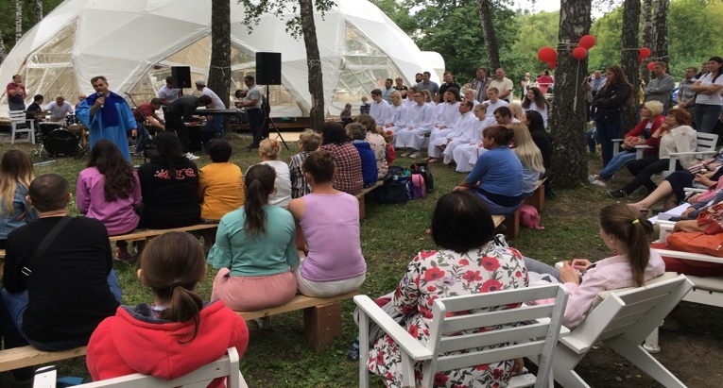
- This year six young brothers and sisters were baptized! We organized a big evangelistic baptismal service for it
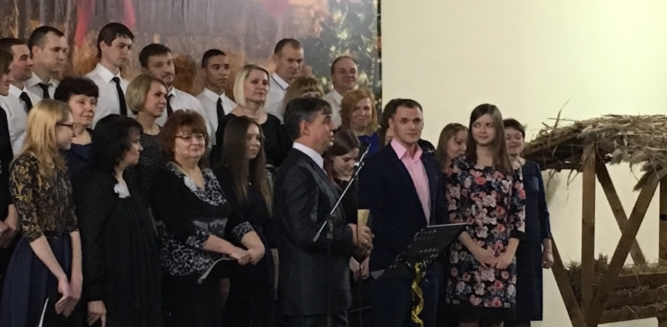
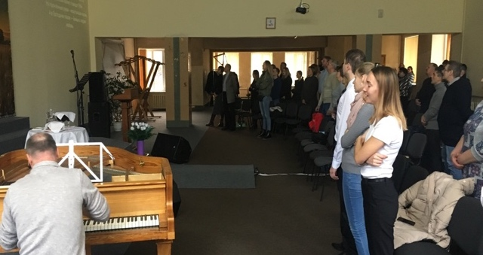
- Nowadays we are getting ready for a Children Christmas play on Jan. 5, and for the big evangelistic Christmas Eve concert on Jan. 6! Please pray that many new people would come and be saved!
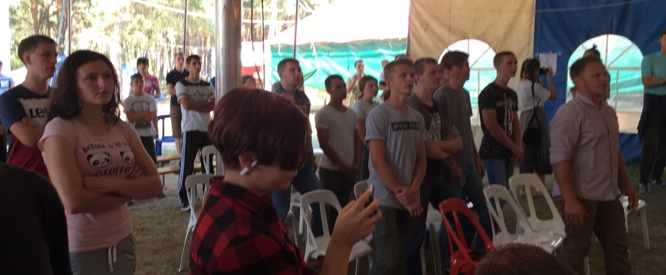
Preaching, Teaching and Evangelism
I praise the Lord for using me, besides preaching and teaching in our NT church,
in other ways as well:
- I served/preached at evangelistic and youth meetings,
- Thought a seminar during the Gypsy Christian fellowship,
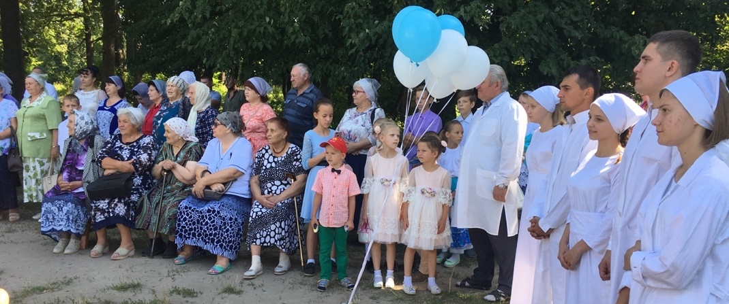
- Presented a topic at “Church in 21 st Century” at Kursk area ECB Congress this summer,
- Participated in Kursk Ministerial meetings and in several baptismal services.

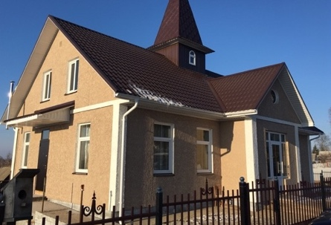
More Good News: Our recent Kursk area Ministerial meeting was held in this new church building! Kursk area churches together have built it very fast in a little town of Fatezh, 35 miles away from Kursk. Praise the Lord!
On this meeting the important decision was made: bless a core team to plant a new church in the northern part of Kursk, where high-raised building neighbor-hood for 50+ thousand inhabitants was built recently. Praise the Lord!

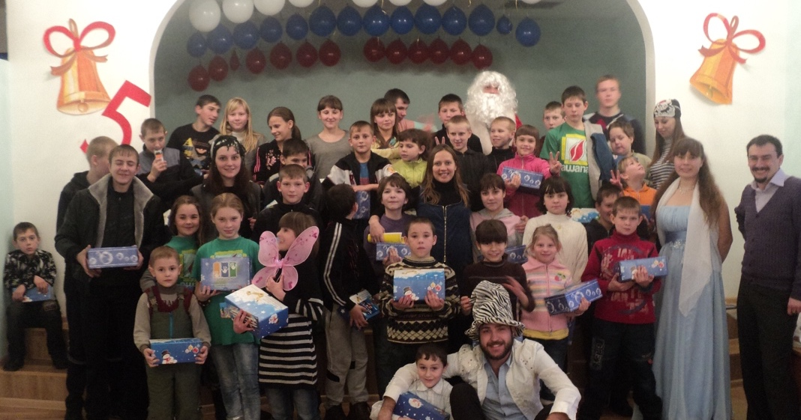
Christmas for orphans:
Three youth teams are getting ready to visit seven orphanages with Christmas presentations, plays and gifts. No election campaigns for gov. offices are going on this year in our area, so, no candidates are going to show up in the orphanages We are the faithful ones who come to the orphans no matter what .
So, we have got more open doors of the orphanages, but we have less resources this year.

Summer camp ground was purchased recently, praise the Lord! We are working on bringing to this ground electricity, simple access road, 40fts used container as storage, and water well. So far everything is going on well, praise the Lord! Please pray for God’s blessing and protection of this land development from the evil ones.

If you have any money left after your Christmas celebration , please send a check to:
Christ Centered Homes P. O. Box 777 Atlanta, TX 75551
Christ Centered Homes is the non-profit organization, which oversees this ministry and serves as the advocate for Kursk Ministries. Christ Centered Homes will send you a statement for your taxes.
Our various ministries would really be happy if you would give them their hand!
May God bless you abundantly and lead you in all you do!

With Christian love,
Igor Petrov and Kursk ministry team. https://kurskministries.org

