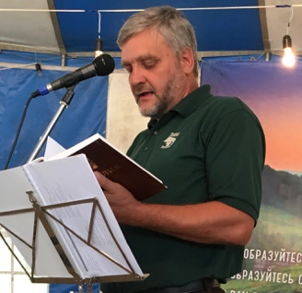
Dear Friends!

Sorry for my long silence. As you probably know, my dear wife Svetlana went to be with the Lord four years ago. I am doing better now and able to write

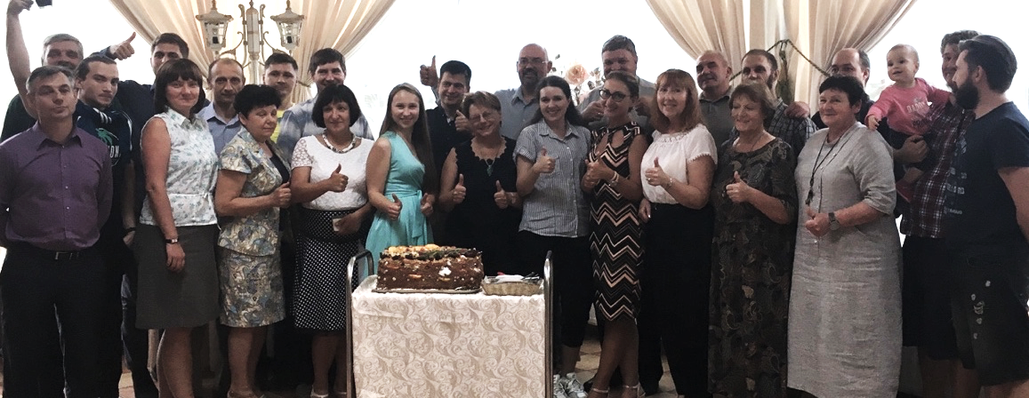
I continue my service with TVSeminary.
It grew really big: over 4 thousand students from over 30 countries enrolled online, plus about 1300000 view of our video courses in three years!
Praise the Lord!

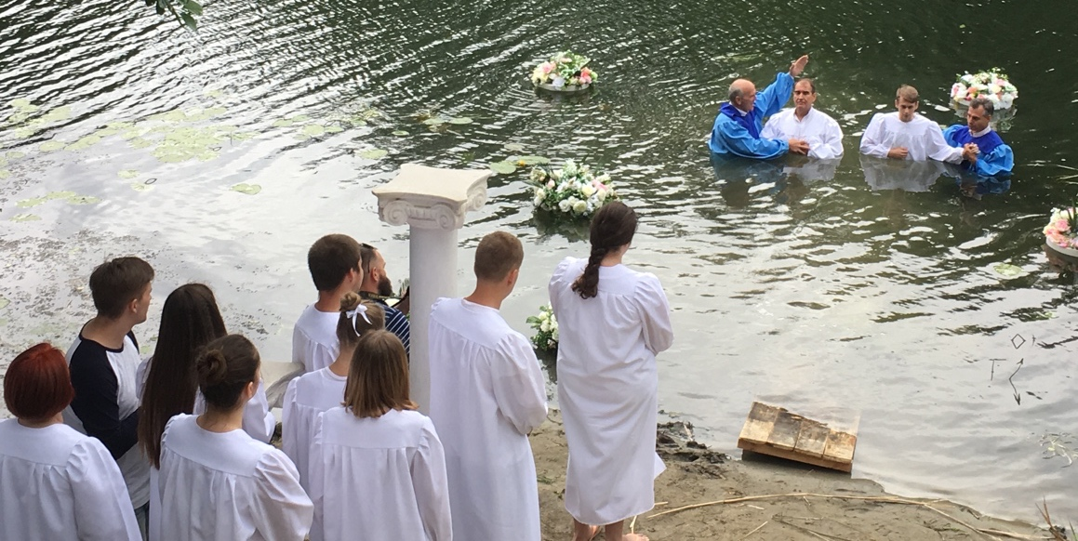

I continue to serve in our local church as minister, preacher, teacher and helper.
This summer we baptized 6 young believers:

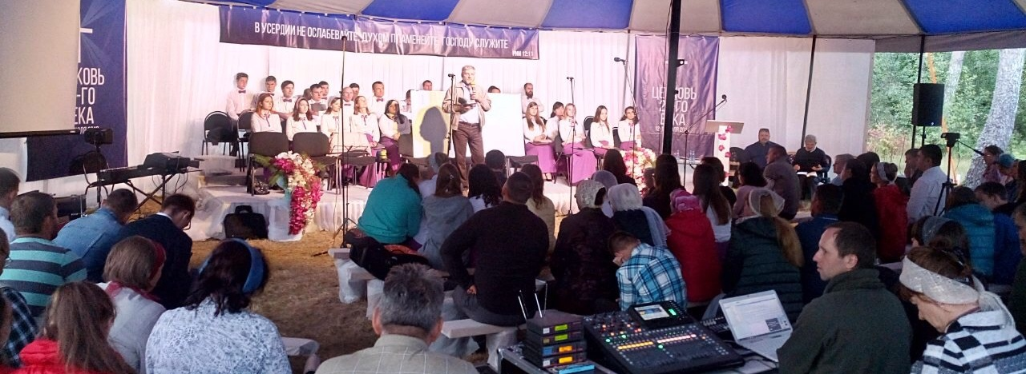
I am also often invited to preach on various evangelistic events or youth events. Like preaching on this big Kursk area congress this summer:

Last week I led a seminar during the Kursk Gypsy fellowship:
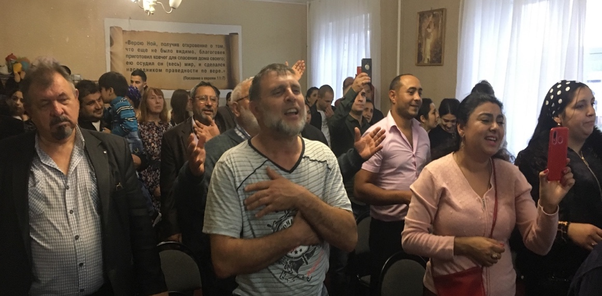
Gypsy Christians and these who are interested came from various churches of Russia and Ukraine. Their prayer is like a fire! Their singing is extremely moving, talented, touchy and it stirring up many emotions!
I was captured by their songs and they let me go free only after I told them everything I know on Joshua 24: “As for me and my house we will serve the Lord”!
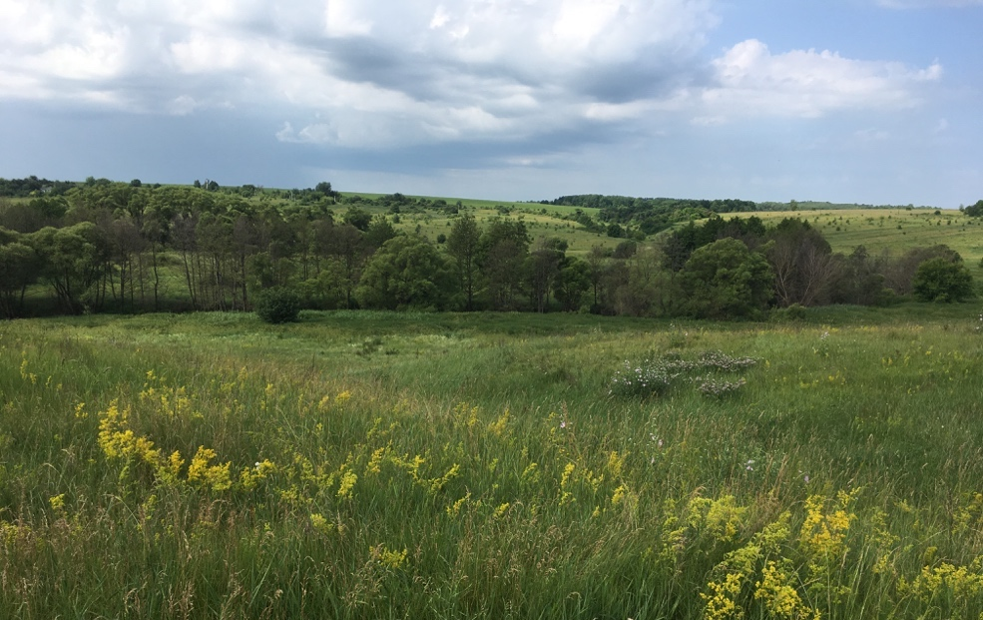
This Saturday, Nov. 16, 20-30 Kursk evangelicals’- volunteers are determined to finish planting 7000 pine trees around the land, which I recently purchased (very cheap!) for our Kursk area Churches’ association Summer camps. Yes, we purchased this land, God answered our and your two-year prayers!
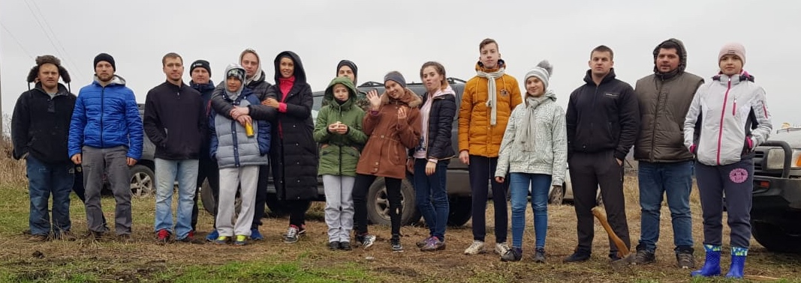
Last Saturday we already planted 3500 pine seedlings. I continue to work on bringing electricity, access road, water well and storage container to this land by the next summer, if the Lord permits and if He continue to provide His support and protection.

In the future we plan to build simple sport/play ground on this beautiful land, swimming pool, kitchen and a big tent for many kinds of evangelistic meetings, concerts, summer vacations, family fellowship, retreats etc. Please pray for it.
I see it as the final big project in my life.

Today, Now 13, I got a call from a lawyer, who helps us to change our camp land zoning from agricultural to recreational. She found out that we need to order/develop full plan for all 5 acres of our land, reflecting all the road and walkway schemes, electricity, water, barns, kitchen, swimming pool, sport and play grounds, etc.- everything should be reflected on this plan. It will take $4-5K and about one year to develop and get all the necessary services approvals: sanitary, fire, ecology departments, village board, and even Kursk area Governor’s signature. It concerns me. I hoped it would not be so complicated. I am determined to develop this land gradually, using mostly money coming from our nursery. Such unexpected expenses will slow it down. But, I put my hope and my trust in the Lord! We will very appreciative if you would give your hand and speed up this process Please pray for this situation.
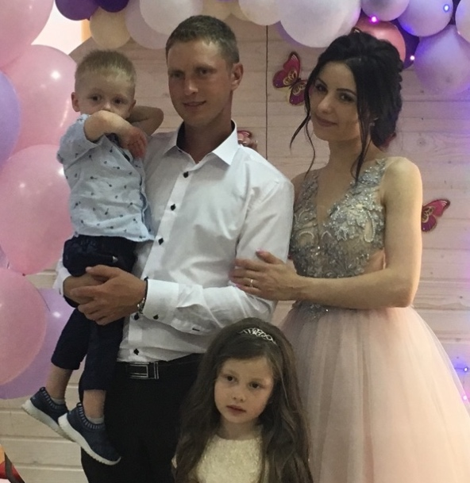
Family news:
You can see my middle son Andy on the pine planting event which he organized (see pic. above, Andy is second from right). He is not married yet Oh. . ..

My older son Victor and his wife Kristina have two children and they bring lots of joy into my life:

My youngest son Cornil is now working for Toshiba Co. in Moscow, he is installing CT (computer tomographs) all over Russia. On this picture he is in Amsterdam during the annual training for his profession.

I really need your prayers for God’s protection, wisdom and leadership in all the ministries, things a getting harder for evangelicals here. Especially pray for our summer camp development.

We would like to hear from you and know how we can pray for you! God answered many of our prayers The secret of answered prayer is to stay in His will
With Christian love,
Igor and your friends/brothers/sisters in Christ from Kursk, Russia

