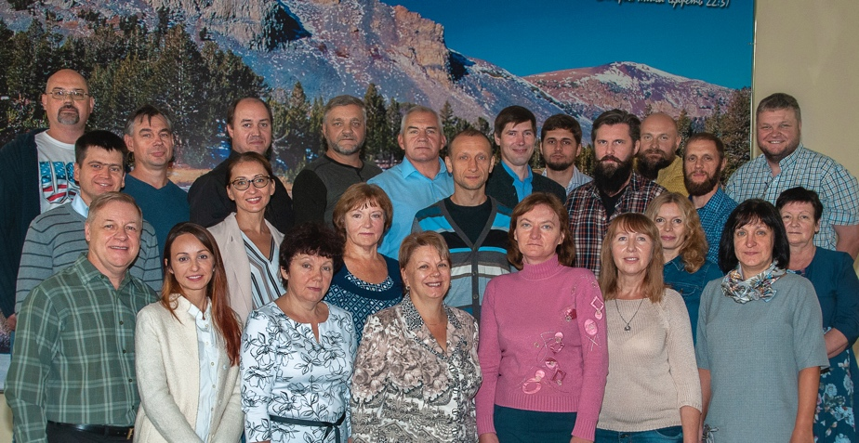
Merry Christmas from Russia!

In spite of growing pressure, we thank God for many blessings in 2018!
We are thankful for 8+ new master level courses videotaped in TEDS by our TVSeminary specialists Daniel and Nina Poluchin!
We are thankful to serve over 3500 students registered at our school! http://en.tvseminary.org

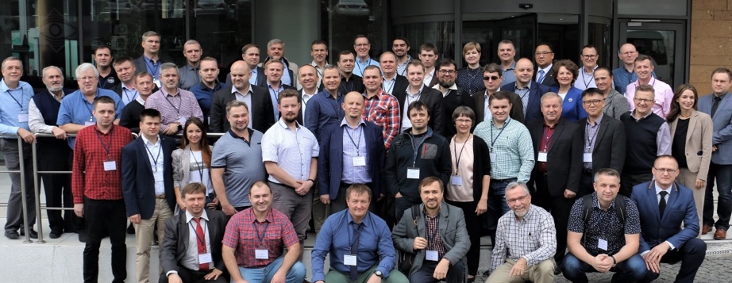
We are thankful that TVSeminary has become the largest evangelical school serving thousands of pastors, lay leaders and hundreds of thousands various viewers all over the world! We honored to be a useful vessel in His hands! https://www.youtube.com/user/TVSeminary

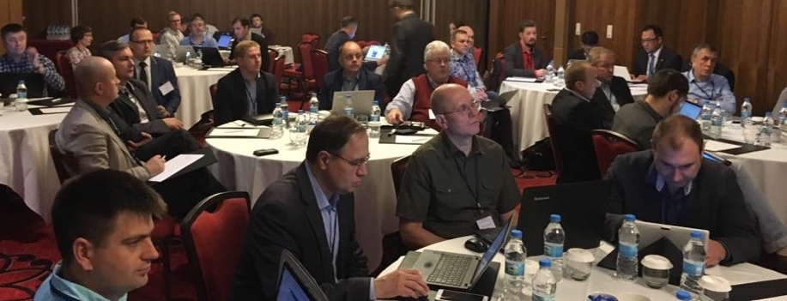
We are thankful for EAAA, (EurAsian Evangelical Schools Accreditation Association) conference held in Stanbul /Konstantinopolin Oct. 2018. Most of the seminars there were led by TVSeminary, because we are the leading online school in this area. We taught school leaders how to develop their online teaching/learning. I led a section on educational aspects of online learning. Praise the Lord!

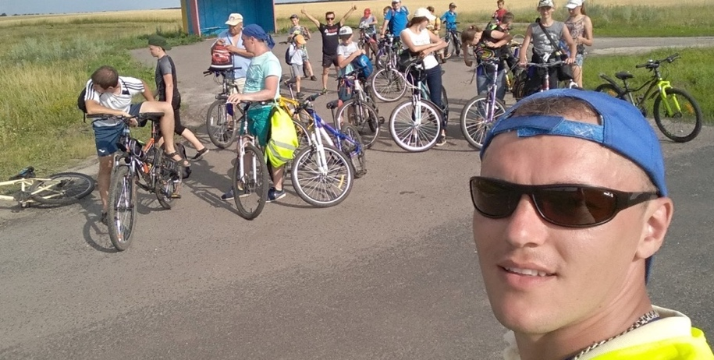
We are thankful for the bicycle evangelism organized by our youth team this summer. As I shared before, we lost our summer camp ground this year . We prayed a lot to see what we can do under such dark clouds. So, God led us into this new way of evangelism! No restrictions placed on the bicycle trips in Russia yet .

We are thankful for four smaller summer camps conducted in Kursk area as a “simple family events”. God is still in soul saving business!

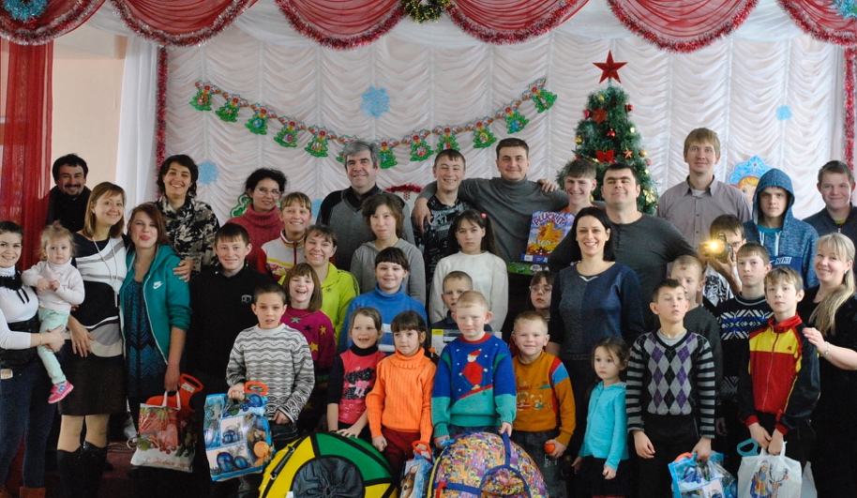
We are thankful and praise the Lord and all our friends for good amount of money accumulated for the camp ground purchase so far! Several times we were close to purchase it, but it did not work out yet. Please pray for God’s leadership and His wisdom in this very important matter. We do not know to what extent the restrictions on us, “western agents’, will tied up in our country. Please pray for our protection from all evil doers. We mean it, it is real, we see more restrictions: since antimissionary law was implemented there were over 140 courts filed against evangelicals in other parts of Russia.

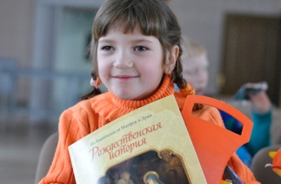
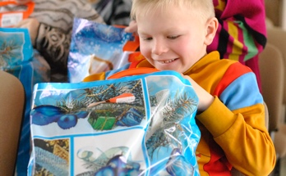
We are thankful for the orphanages allowing our youth teams to visit them with Christmas presentations this year. Because of harder economic situation, caused by US|EU sanctions and low oil prices, much less politicians and businesses show up to help orphans. Thus, God opened hearts and doors for these who really bring God’s love to the orphans! We are getting ready for these big outreaches in Kursk area in Feb 2018-Jan 2019.
Please pray that over 430 orphans would hear the Good News and get their New Testaments and other gifts during this coming Christmas season!

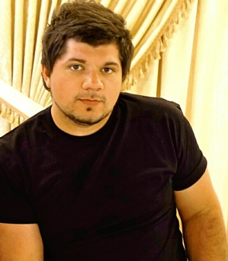
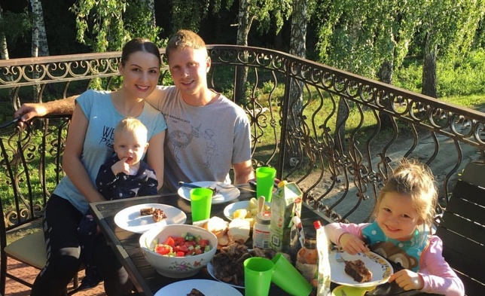
Petrov Family News:
We are thankful to you all for your prayers for my grandson Bogdan! Praise the Lord, the operation on his open heart was total success! He is doing very well!
God hears our prayers!
Victor and Kristina are doing well while they have something to sell: fruit trees and shrubs, strawberries and raspberries during the warm season. These days Victor is looking for the job to feed his family until the spring season comes on his nursery. It is hard to find a job in Kursk now. Monthly salary for “people with no connections” – $250-350. One can survive on it only if he/she has grown and stored in the cellar lots of potatoes, hundreds of jars of canned fruits, vegetables and some meet.

Andy, did everything to keep our nursery “in black”. This year was not easy: western sanction hit Russian economy even more, so people buy much less. Beautiful plants are not the priority at all, food is.
Andy is not married yet. Please pray that his heart would be drawn nearer to the Lord.

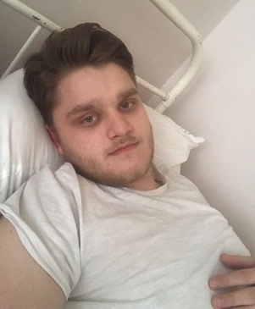
Cornil graduated with bachelor degree in medical engineering from Prague Technical University. Praise the Lord! He was about to start working for Toshiba in Moscow, but when he was collecting all necessary papers for the employment, he got so close to be drafted into the army service. His blood pressure went high, so he is in the hospital now, for better or for good At least he will not be drafted. We do not want him to “fight for freedom and justice” outside of the country boarder.
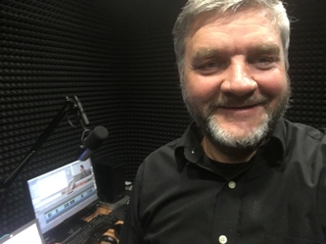
Igor: My health is in accordance to my age (58) . Disregarding my diabetes and heart weakness, I am able to run (not as fast) ,
to cook, clean, preach, teach, talk, translate/dub the courses, strategically plan, share the vision and write! Praise the Lord!

May God bless you abundantly and lead you in all you do!

With Christian love,
Igor and Kursk ministry team.
https://kurskministries.org

P.S. Our various ministries would really be happy if you would give them a shoulder!
You can send a check via:
Christ Centered Homes P. O. Box 777 Atlanta, TX 75551
Christ Centered Homes is the non-profit organization, which oversee this ministry and serves as the advocate for Kursk Ministries. Christ Centered Homes will send you a statement for your taxes.

