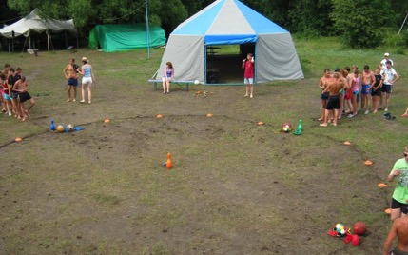
URGENT! We lost our ‘Island of Hope’.

Yesterday, May 25, we found out that island on the river near Kursk, which Kursk evangelical churches and ministries had been using for Summer Camps, was occupied by someone. Bulldozers are working there already.
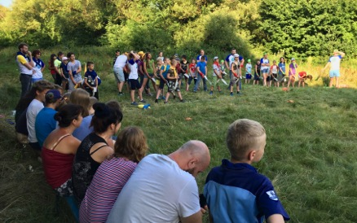
For over 20 summers we used this Iceland ground for 5-7 shifts of children summer camps, various retreats, youth conferences and family trainings. It served as ‘Island of Hope’ for many thousands of our and unchurched kids, youth and adults, who heard clear Gospel message there. Many hundreds of souls were saved there! We praise the Lord for His great saving power and many blessings, which He showed there! We even did not have to pay for very intensive use of that island each summer!
These days we, summer camp leadership and pastors and youth leaders of Kursk area churches, are prayerfully considering purchase of land, which would belong to local evangelical churches. So far we visited 4 lots of land for sale.
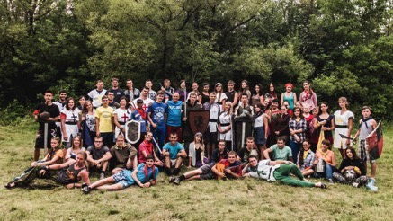
We really need God’s leadership and His wisdom in this situation. We have to consider several issues:
- Today local mass media and propaganda considers us, evangelicals, as ‘agents of western influence’. Local authorities will do all they can to stop this very effective ministry, which ‘steals our children’s souls’, as some of them say. Therefore the land should be in a quiet place. We don’t want to bother any neighbors with our music, games and evening worship services as we use our sound systems.
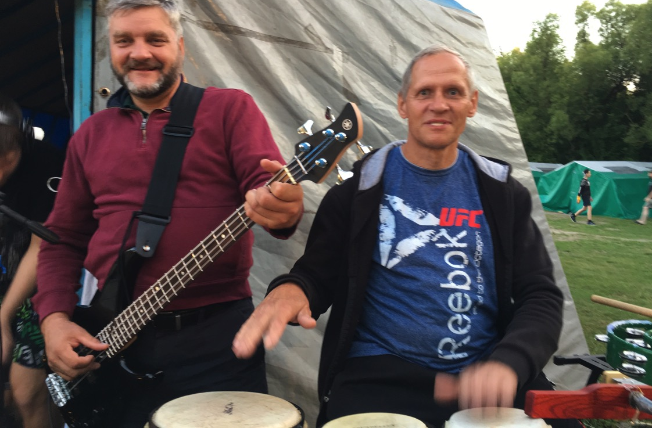
- We need to comply with all the sanitary, fire, ecological, safety and other rules and regulations. Several evangelical summer camps throughout the Russia were closed because of these issues so far.
- We have raised money for the purchase of camp land so far, but, most likely, it will not be enough. We will surely need significant finances to make a ground access road a bit more ‘friendly’, to build fence, bring electricity, drill water well and build a small building, to store our tents, kitchen, showers, sport items and many other equipment.

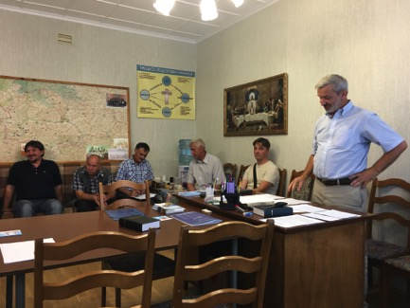
Please pray for us and for this situation. We really seek God’s will and want to glorify His Name!
We lost the iceland, but we do not loose our Hope in Christ!

If the Lord moves you to give us your hand in this ministry, please send your support through Kursk Ministries via:
Christ Centered Homes
P. O. Box 777
Atlanta, TX 75551

Christ Centered Homes is a non-profit organization, which channels all supports to Kursk Ministries with no allocation fees. Contact us or Mark Hill (mark@christcentered.info) if you have any further questions.
Christ Centered Homes will send you a statement for your taxes.

