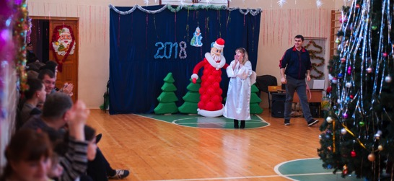
Another Christmas?
Another special Christmas, when we can not just know that Christ was born for us, but also share this joyful message with those children who do not have caring and loving parents. And at this wonderful time, thanks to you, not indifferent people, every boy and girl could receive a gift with a piece of light and warmth!

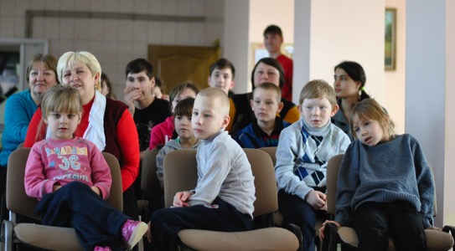
The process of completing and arranging the gifts is also noteworthy for us. This is why orphans-graduates of boarding schools participate in this event. Not so long ago they received such presents themselves and remember well how much joy and impressions were on the day of arrival, with what interest they considered their gifts and their friends. Because of the call: "Natasha, could you help with completing gifts to the orphanage?", I hear a joyful: "Of course, when and
where should I come?".

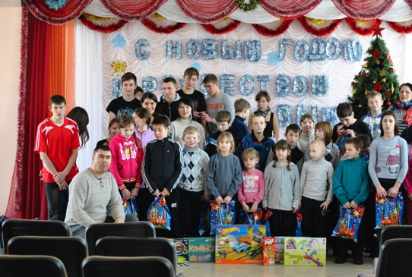
And Galya only learns to do good. It is still difficult for her to give anything without receiving anything in return. But when, this girl saw our small but enthusiastic team, our warm conversations and fun during the collection of gifts, she could not resist and joined us. It turned out that it's very nice to complete gifts for others.
And again special trips to boarding schools. Each time they bring a lot of emotions of joy and emotions, meetings and new acquaintances.
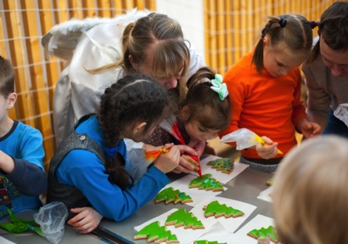
One of the participants of our program played the role of an angel. She was approached before the beginning of the event and got acquainted with
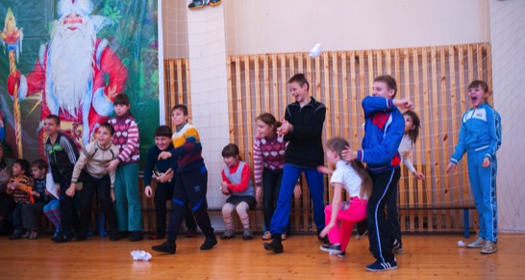
the guys, a little girl Vera came up to her. She embraced her and asked: "Mom, are you an Angel?" Take me with you. I have absolutely no one at all. " She again and again stroked the "Angel" on her arm and did not want to let go. Next to her was a high school student who helped Vera, who had recently come to their boarding school. Lera said that she has a big family, brothers and sisters. And she really wants to be with them when she finishes school.

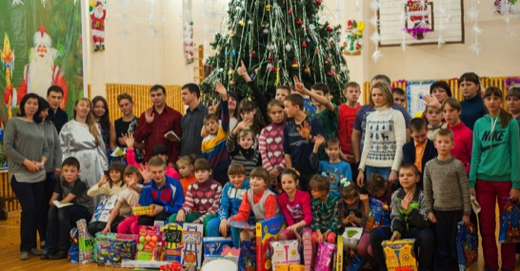
Such stories leave wounds on the heart, bring sadness. But they also force our hearts to be not indifferent, to pray even more for the children in orphanages, and to help them as much as we can.

We are very glad that this time God allowed us to hold master classes for decorating Christmas gingerbread and making Christmas toys out of felt. The boys and girls were delighted, vying with each other to share their impressions and want to show what they did. For them it is a small achievement, though. And some could not resist not to try honey gingerbread taste.

By the end of the meeting, we have already become acquainted with many children, learned about their aspirations and even dreams. After looking at their gifts, the boys and girls approached and thanked again, since they did not have such gifts this year.
It was sad to leave, because each participant of our team left a part of his heart with these children, in these orphanages.

Thank you for making it possible to make Christ's Nativity Day special for children whom their parents do not need.

May the Lord bless you !!!

Olga and Eugene Pavlov on behalf of Kursk Orphanage ministry team
P.S. Gigrs who finished orphanage earlier received nail care kits. Now they can make extra income at home by providing lail services. This is popular in Kursk now.
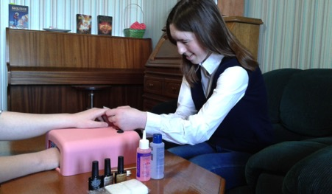

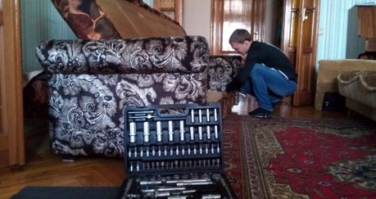

P.S.2 Young men who finished orphanage earlier received tool kits. Now they can make extra income by fixing or assambling furniture or fixing the cars or bikes for the customer at their homes. This service is in demand in Kursk now.

