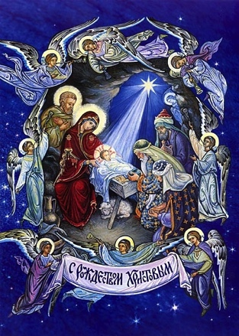
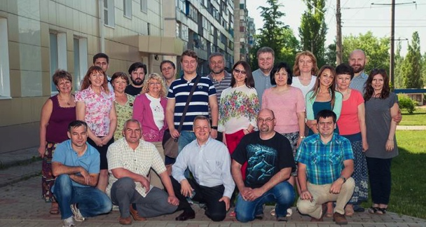
Merry Christmas, dear friends
and co-workers on God’s fields
in Russia!
Despite of growing pressure on evangelicals in Russia, we thank God for many blessings in 2017!
TVSeminary statistics from our Youtube channel: https://www.youtube.com/user/TVSeminary/featured
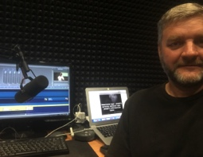
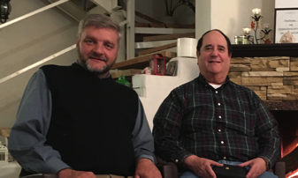
269 128 - viewings in 2015; 345 012 - viewings in 2016
586 333 new viewings in 2017; TOTAL - 1 290 409, while average vieving time ranges between 7,29 to 19 minutes. Praise the Lord!

We are reaching many people through this free channel with good and deep teaching from God’s Word! And many of them are nonbelievers!
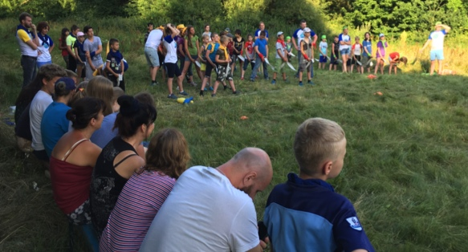
These who want to take our courses for credit use our Moodle platform. http://en.tvseminary.org
So far over 2700 learners from over 52 countries have registered and we have received hundreds of thanks and appreciations from them!
We uploaded 14 new courses (187 hours) this year, bringing total number of courses available up to 66! We also dubbed 6 courses (I am working on Theology III by Dr. J. Feinberg now).
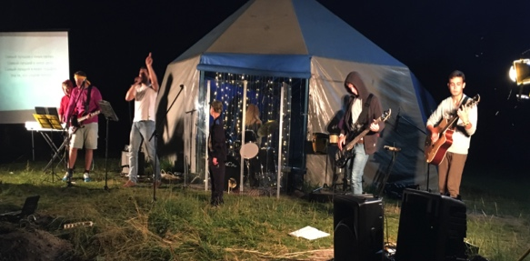
In June 2017 we recorded a new course on Apologetics and Epistemology with Dr. Feinberg https://www.youtube.com/watch?v=RgPe2aS3y6Q
Two more master level courses were videotaped by our team in TEDS, IL. More – next semesters!
Dec. 5-9 I was participating in the Evangelical School concil and Evangelical Theological Society held in Moscow Theological Seminary. God has really blessed our TVSeminary to serve so many school via our courses! It is such a blessing to hear many school leaders praising God and appreciating our team for so many great courses they use in their programs! Praise the Lord!

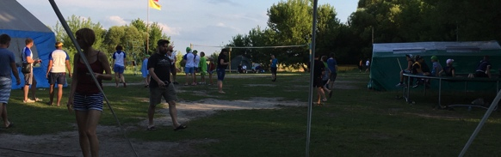
This summer we still were able to do our summer camps. Seven shifts, 45 to 75 kids plus 25-35 serving adults in each. Our shift was great, overful, many kids came back home changed by Christ! We thank you so much for your prayers and support, please keep lifting your hands in prayers and keep giving your supporting shoulder!
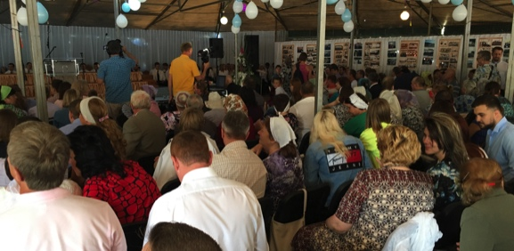
Many evangelical summer camps in Russia were closed or not allowed this summer. We do not know where and whether we will be able to do our summer camps next year. This is our big concern, please pray.

On August 2017 Kursk area evangelical baptist churces conducted big celebration of 150 Years of Evangelical Movement in Russia, Praise the Lord! The central city beach was rented, great church choir, solo poetry and preaching were given before the water baptism.
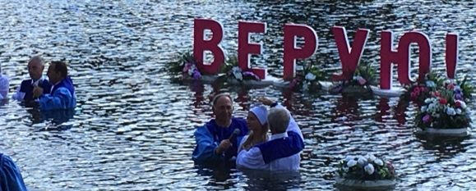
I presented the history of evangelical movement. You can watch this joyful day here: https://www.youtube.com/watch?v=Aik5x-FRdM8&feature=youtu.be
I can not say how many hundreds of believers and guests came, and how blessed and encouraged they were! Because local procecutor's office and intelligence were wery concerned about our fest. Looks like they will not allow such «prowestern sectarian activities» again.
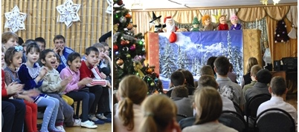
We are «between two rocks in the hard place», these who do not like what US government is doing internationally, can not reach you, but they can easily reach us . We are not «prowestern», we stay away from all politics. We love our Lord Jesus Christ and we are good, honest, hard working citizens. But it is hard to explaing to these, who were heated
by the local propaganda. Please pray for our protection!

Only seven orphanages still allow our youth teams to visit them with Christmas presentations, we are getting ready for this big outreach in Kursk area in January 2018. Please pray for open hearts and doors for these who are going to carry God’s love to the orphans!

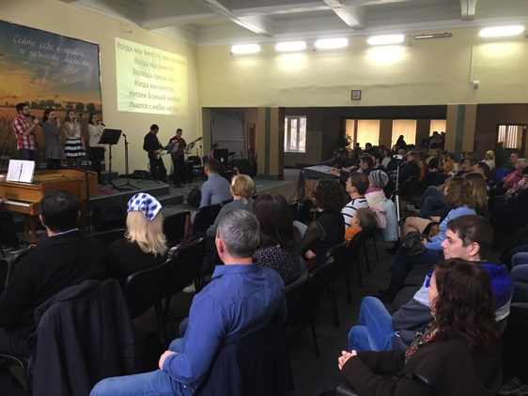
Our New Testament Evangelical Church is gradually growing,
I continue to serve as a chair of elders, preach monthly and lead SS class weekly, if not visiting other churches. On Russian Christmas Eve, Jan 6, we are going to have Christmas Concert in our church, and on January 7 – Christmas for kids in the morning and Youth Christmas on the afternoon. Praise the Lord and pray for these big outreaches! According to the new restrictive law, we can do such outreaches only in our church building. Since summer 2016 over 200 law suites were filed against evangelicals in Russia.

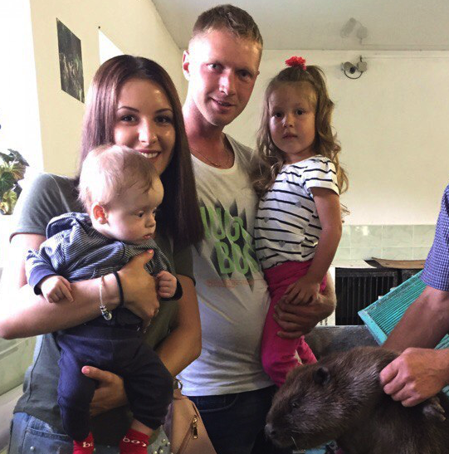
Petrov family news: my sons and grandchildren keep me very busy. I am allowed to watch for Alice, to take her to Sircus or Doll Theatre. She is a blessing!
My 10 months old grandson Bogdan (his name means «God's given') was diagnosed with heart problem. It requires an open heart surgery. Victor and Cristina (Bogdan's parents) are getting Bogdan through all the preparations for this surgery, which is planned to be done in Moscow next year. With Russian government support for such operations, the remining cost is still going to be huge for us– about $5800 to $6000. We all would really appreciate if you would pray for Bogdan and help us in this matter.

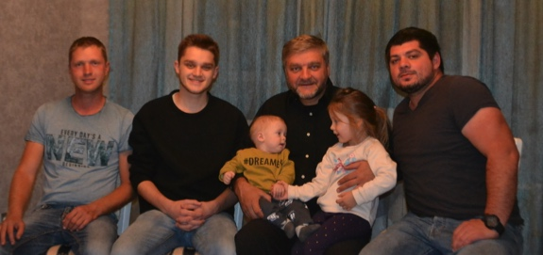
My youngest son Cornil still has to finish couple of courses and graduation research for his bachelor degree in medical engineering in Prague Technical
University. As I look at my diminishing resources in our bad economy, I realize that, Lord willing, I might be able to provide for his
housing and living expenses, since he spends minimum on himself, but I will need help in paying for his jaw surgery in Jan 2018 (Note: do not let any babies to ruin their teethes and, consequently, their jaws, by using pacifiers! ). We would really appreciate any possible help in this matter.
My middle son Andy (right on pic.) is such a good, kind, hard working young men. He takes care for our nurcery and keeps it even somewhat profitable in spite of bad economy, but he needs to be closer to the Lord and to be married, ohh . . . My dear Sveta was able to talk to sons about it . . .
I am not good at it . . ..
My health is in accordance to my age (57) . In spite of my diabetes and heart weakness, I am able to preach, teach, talk, think, translate/dubb, strategically plan, write and even work a little bit! Praise the Lord!

May God give you a very happy Christmas and many blessings in the year ahead!
May He bless you and lead you in all you do!

With Christian love,
Igor and Kursk ministry team.

P.S. You may want to send a check:
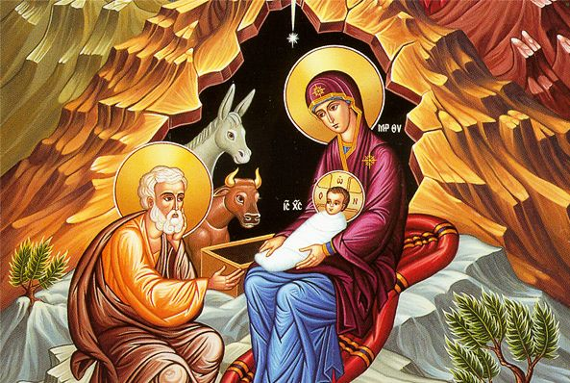
Christ Centered Homes P. O. Box 777 Atlanta, TX 75551
Christ Centered Homes is the non-profit organization, which oversee this ministry and serves as the advocate for Kursk Ministries. Christ Centered Homes will send you a statement for your taxes.
Please let us know what particularly you would like to support

P.S. 2 Have you even been sent by you computer
to the page error 404?
It is real and it is in Kursk area:
