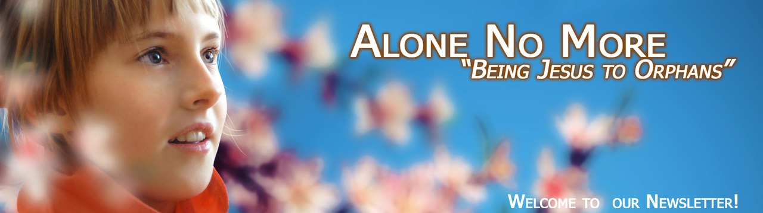
“But now is Christ risen from the dead, and become the first fruits of them that slept” (1Cor. 15:20). We are grateful to our Savior for His great love to us, for His death and resurrection! We are grateful that “God commends his love toward us, in that, while we were yet sinners, Christ died for us” (Rom. 5:8).

And now we are called to minister to those who don’t know Christ yet,
who don’t understand his endless love to everyone.
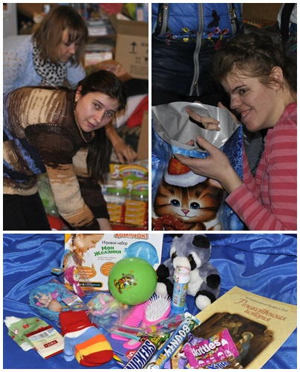
Dear brothers and sisters in Christ, we are grateful to God for the opportunity to share the Good News about our Savior with the children who are abandoned by their parents.
We are grateful that we together have an opportunity to demonstrate our love to them. We remember how we were visiting our regional orphanages during a month before Christmas telling boys and girls there about the birth of our Savior! We managed to visit six orphanages and a group of disabled children then. Preparing the gifts this time was very special: two girls, orphanage grads, helped us do it. One of them, called Natalya, was from the Gornal orphanage; she was helping us days and nights, no matter how tired she was. She said, “I do remember how your team visited us there. We all had been looking forward to your visits! After you had left I was looking at the new pair of gloves, the comb, the game and the sweet things you had given me as a gift. How wonderful it is that this year the children will get such cool presents”.
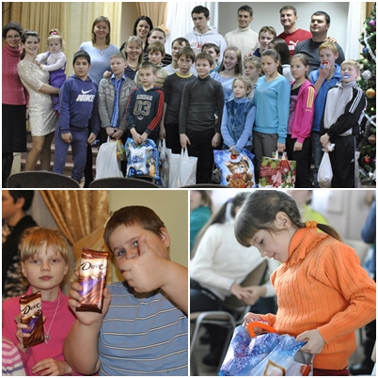
About 500 children managed to see our Christmas puppet show; we played games with them, we sang together, we just talked and they shared with us their successes and worries. They also got the gifts that reminded them of God’s love.
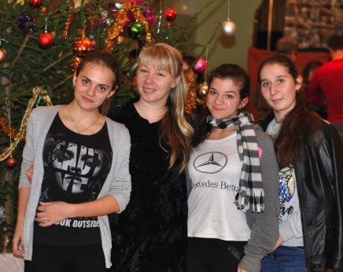
During our Christmas activities we met many new friends and saw the children we had not seen for a long time. They moved from one orphanage to another. We are in contact with many of them now. We meet with some of them personally and we communicate with the others via the social networking sites.
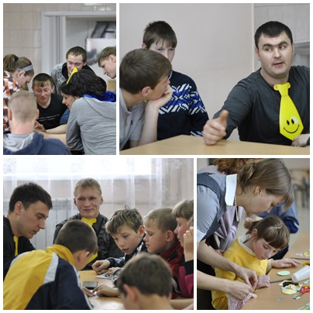
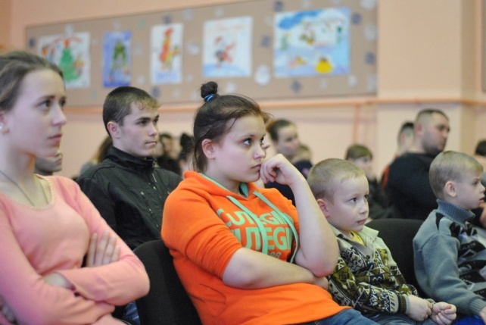
Some time ago we were happy to meet with the girl we had not seen for a long time. We could not be in touch because she had been transferred to another orphanage. Now Galina is finishing school. When she saw us she immediately began sharing about what was going on in her life. She said, “I have found my biological elder brother and we are in touch with him. I want to be a hairdresser. I am dreaming of becoming a really good specialist. Now I have some practice doing my classmates’ hair. I also participate in the Independent Life Teaching program. Thanks to “The Flight School of Life” lessons I can cook well and do it much better than all the other girls and boys here”. We were happy to hear the news and to rejoice with Galina.
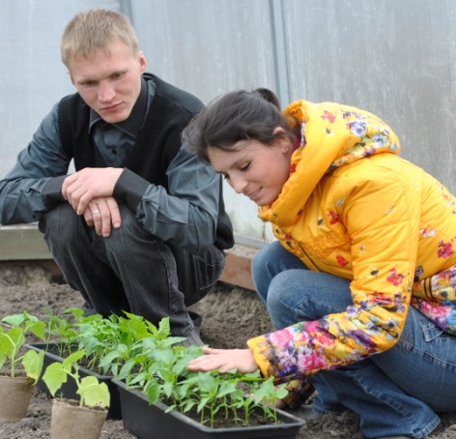
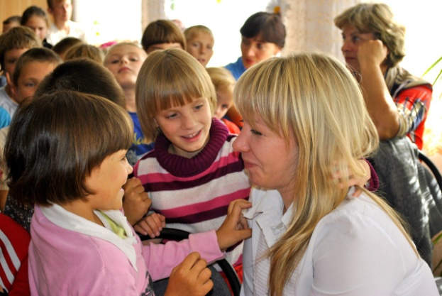
Some time ago one of the orphanage girls found my wife in a social networking site and wrote to her there. She mentioned that she had been taken custody of and had a mother and a father. She told us she loved them dearly. And she added she remembered about our meetings and was missing them.
Last week we visited one of the orphanages and learned that the boy called Ivan needed glasses. He had been in this need for several months already. His eyesight is very poor and he seeing unwell is laughed by the other children at. He needs special glasses that are very expensive. We are praying to be able to help this boy with this need.
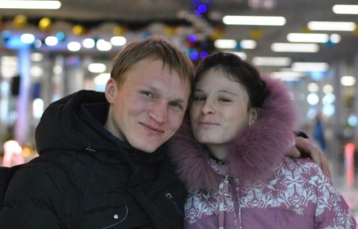
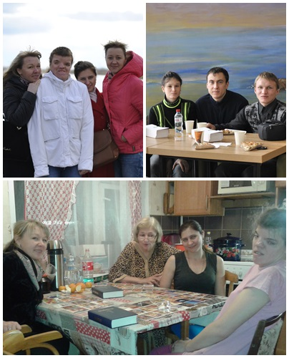
At the “Training Farm” the spring season has started. Lena and Sasha are growing seedlings for two greenhouses. We teach them to grow new kinds of vegetables this year. Two weeks ago the goat had two young kids. And one more young goat is expecting.
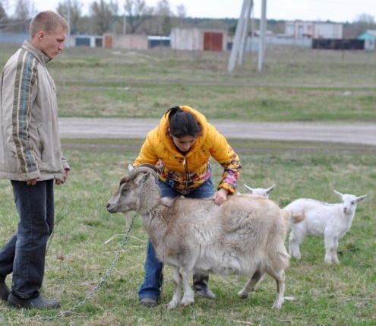
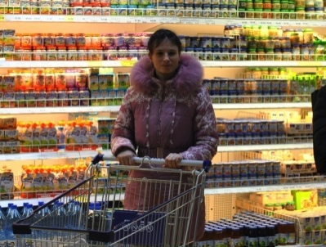
Recently Lena and Sasha celebrated their 5th anniversary. We were happy to know they were going to make pleasant surprises to each other. Praise God! They don’t have wedding rings and Sasha decided to buy a ring for Lena as a sign of his love and their marriage. And Lena bought a fishing rod for him. It was his dream. And some time ago after the last snow had melted Sasha also gave Lena a beautiful bouquet of the first flowers. It was also a great surprise. They keep gaining family life skills: they learn to plan the family budget; they work at distribution of responsibilities and help each other when necessary. Lena is still battling with the fear of doing shopping in big supermarkets, but now she is much better with it.

During the Easter days we talk a lot with the participants of “The Harbor of Kursk” and “The Training Farm “ projects about the meaning of the sufferings, death and resurrection of Jesus Christ. We are praying for all the projects participants to accept Christ in their hearts. We want their lives and their hearts to be transformed completely since we know that life with loving God is the most wonderful thing in one’s life.
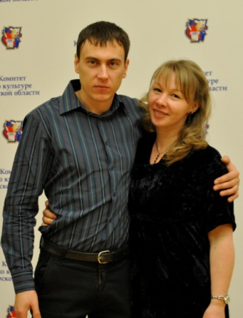
We are grateful to God for you, for your support and for your love to the orphans!

Yours in Christ,
Evgeny and Olga Pavlov
and «Alone no more» ministry team.

