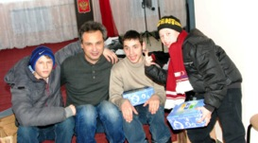
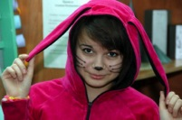
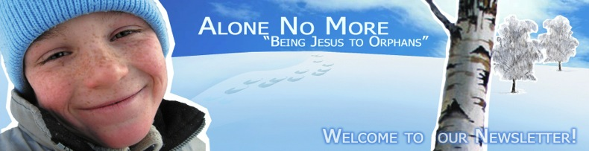
…Some hours before our Christmas proclaiming trip to the Ivanovsky orphanage there came a SMS warning from the Rescue Service about the coming snowstorm. But it couldn’t change our plans since the children were waiting for us. The road there was terrible. Snowstorm, strong wind, slippery roads and snowdrifts made it very hard. From time to time we met big trucks, cars and SUVs stuck in the snow on the roadside.
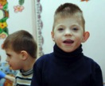
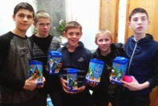
The children were happy to see us: they had been looking to it for a long time. They were missing us. Under the pressure of circumstances we had to change our Christmas program in process. Our ministry laptop died few months ago. The other PC from our friends was old and we didn’t manage to open the videos, songs and the puppet show music files on it. I am grateful to God for our experienced volunteers: they know how to work with kids. They managed to involve them in fun games and to tell them Christmas stories without any aids. I don’t know why God allowed all these trials.
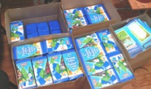
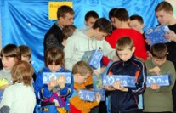
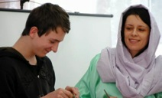
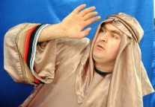
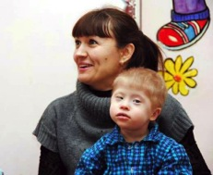
But His blessings were above all troubles! When we were congratulating the sick children from the preschoolers’ group telling them about the Savior and playing games, a boy came in. He was an orphan of 7 years of age, Nikita by name. He had a Down syndrome and could not walk. Usually his teaches carried him in their arms. He hearing the noise of the playing children got out from his bed and walked into the room himself! I managed to take a picture of the teacher looking at him in great surprise! She was just over the moon! I can’t say exactly what it was: either the work of the Holy Spirit, or just great motivation for the boy to walk… Anyway, it happened by the will of our Lord Jesus Christ! And we are ready to have any trials and to sacrifice a lot for the sake of seeing such happy moments! I prayed over this child for him not to lose this skill. We all know how easier his life and the life of the people around him may be if he can walk!
From the bottom of our hearts we would like to thank all our coworkers in Christ for their prayers and support of the orphanage ministry in Kursk! Through you, dear friends, Jesus gives us the opportunity to share the Gospel with more than 765 orphans and parentless children!
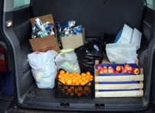
During the Christmas time we managed to visit 11 orphanages, to do 14 outreach events and to give more than 800 Christmas gifts, provided by our dear friends from Dacota. Besides, we had some money for buying some Christian books and calendars, fruit, shampoos, sports equipment, board games and gifts for the orphanage teachers. 32 volunteers from 6 Kursk churches participated in the program.
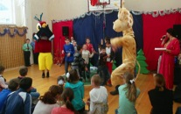
Like in many other countries of the world Christmas in Russia is a family celebration. It makes the opportunity to give every orphan “a piece of love and care” especially important. This is the best gift from Jesus they could ever desire. Praise God and thank you very much, our dear brothers and sisters in Christ!

In Him,
Ilya Fadeev,
The Kursk Alone No More orphanage ministry leader.
