
Peace to you in Jesus, our Lord and Savior, my dear brothers and sisters in Christ!
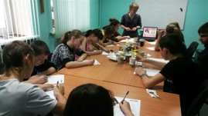
The school year is over; it means that the blessed season of summer Evangelism Projects for orphans of Kursk and Kursk region has come.
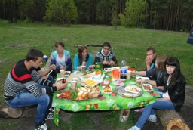
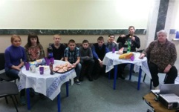
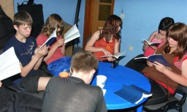
The Flight School of Life term is over. This Project is done for the orphans from senior forms. In spite of the economic crisis and some structure changes in the work of the orphanages our team managed to fulfill all the points of the Evangelism program and the social integration in three orphanages of Kursk and Kursk region. In the project there participated 57 orphans; 180 lessons were done. The teens had good fellowship there, they studied the Bible, they shared with one another about their life experience, both positive and negative and they learnt to cook and to plan the budget. According to the new rules we don’t have the right to share any personal information about the orphans. But when talking personally we are ready to share with you about all the strong points and achievements of the Flight School of Life project. We already have “a line” of 7th form grads that are looking forward to being in the project since September 2015. We offer our prayers to the Lord to have this wonderful opportunity to bless the orphans through this ministry! I am grateful to the Lord for you supporting the project and hope for our further partnership next school year!

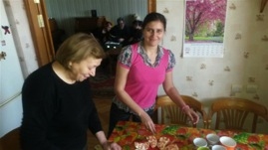
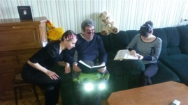
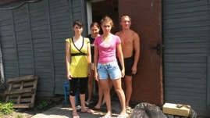
We have also some achievements in the half-way house for orphanages project called the Harbor of Kursk. The main goal of the project is to help the orphanage grads that have no place for living. This year we approved one more direction of this project. It’s care of the place for living for the orphanage grads that have some mental problems. Thanks to hard work of the Christian tutors we help them with adaptation in this complicated world of people’s relationships on the firm basis of Biblical truth. Now we have 3 young girls and 1 young man in this project.
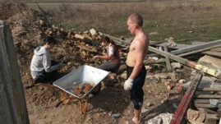
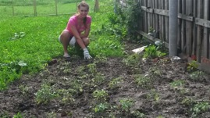
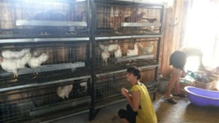
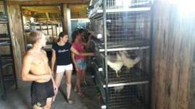
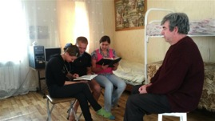
One of the most joyful news for us is the official opening of the Training Farm project. We have been doing the ground work and the construction works during 4 long years. At the same time there were living some orphans there at the farm and we were working with them training them for this kind of work. Now 11 grads already live independently. In May Russlan Velyuhanov finished his training; he got an apartment in the town of Rylsk, Kursk region. Now he can take care of himself. At the farm there live 4 young people now: 3 girls (their names are Elena, Svetlana and Olga) and 1 young man (his name is Alexander). All of them are mentally disabled. With these problems it is very hard if possible at all to find a job. In the fall some more orphanage grads will come there to live. They are from the Lichinovo orphanage (this orphanage is for mentally disabled children). The chicken farm has begun its work; we also have a vegetable garden there and a place for dogs temporary holding.

We are going to open a bakery and a cheese dairy there (we are raising money for these). We hope all this if working well will provide the guys with necessary means for living. Since the project is opened officially we decided to name it after Garry Varner, the person that was the first to support this idea. Though our brother Garry is already with the Lord, his beginning is alive and gives its fruit in the field of evangelism and social support of the orphanage grads who are in need. We are grateful to the Lord for Garry, for his family and for everyone who supports this uneasy work!

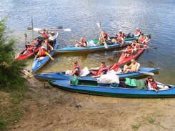
We are planning summer Bible camps and canoe trips.
We are praying to the Lord to help us in sharing the Gospel with as many orphans and orphanages teachers as possible. Please join us in our prayers!

From the bottom of my heart I am grateful to God for your active partnership in the ministry to these poor children!
Yours in Christy,
Ilya Fadeev.
