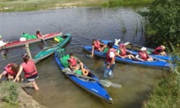
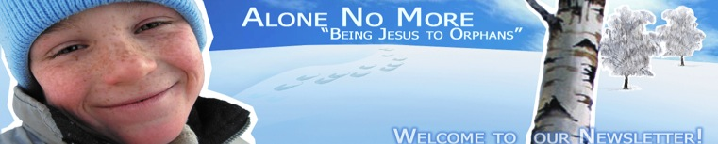
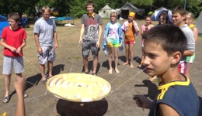
Dear coworkers in the Kursk Orphans Ministry,
PEACE TO YOU!
Russians say "Count your chickens in the fall", that means it is the time to give a brief overview of the summer
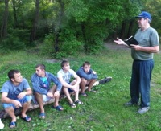
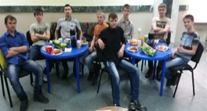
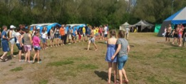
From June through August 2014 our team managed to do two kayak trips and one camp shift for the 69 orphans. Kursk region is very close to the Ukraine, where war still going on, so, we had many complications with the papers allowing us to do all these things. Administration prohibited one more trip, although we guaranteed the security. But we managed to do a lot by God's mercy and care! Having fellowship with Christian tutors, gaining the basics of the Christian faith, the orphans got an opportunity to see the world around them and their inner world through the eyes of Christ and to feel His care, love and faithfulness through the atmosphere of trust created by the tutors and the leaders.

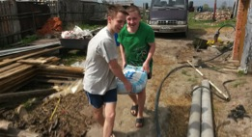
By God's mercy, this fall we are actively developing "Training Farm" Project for orphanage grads. Thanks to your support, we did big land grading, we bought necessary materials for exterior finish of the building and now we are building the fence around the Training Farm.
Good news - the room for a mentor is under construction! It's a significant stage of the work, as the possibility for a mentor to stay there constantly will let us use the time for fellowship and evangelism more effectively. The staircase is already installed and now we are working at the ‘winterizing’ of the room, getting it ready for the cold Russian winter.
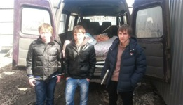
Three young guys are living at the farm now: Victor, Ruslan and Roman. Two of them are orphans and one from a problem rural family. A dedicated tutor has fellowship with each of them; he is sharing about Christ and teaching them life skills. This process is hard and long, as during the years at the orphanage they have lost the connection with the world around them.
After long prayers we decided to do construction works this year, as the farm the construction of which is not finished does not allow us to do our work for the Lord completely. Our main goal is not only to give the shelter to those in need, but sharing the Gospel and teaching the guys to work.
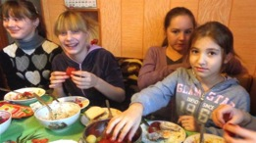
Most of the construction and fit-out works are done by us and orphans. We ask the Lord for wisdom and energy to be able to finish all the works by next fall and to invite more orphanage grads to stay there. This year the orphanage administration has already asked us twice to take some boys for a while under our auspices, and we did it. But we don't have all the necessary conditions to be able to work with all the seven grads at once and the same time. Please pray for the pre-construction activities to be finished in time.

The Christian Project "School of Life Piloting" for senior students of orphanages is moving forward well. Because to our long-term cooperation this project now is included into the list of extracurricular projects of the orphanages, so we can do evangelism without any obstacles!
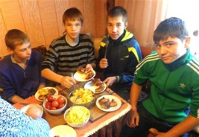
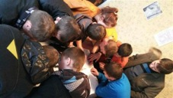
Now we are working at the life stories of this year participants and will gladly send the list and the pictures of the orphans from the Ivanovsky, the Mokva and the Central orphanages for you to join us in prayers for them. Some of them will participate in the Project for the second time. We do it for those who are really seeking God; we are helping them to be stronger in their faith in Jesus . They need a special dedicated prayer support.

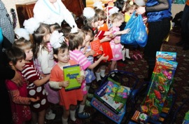
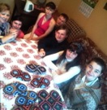
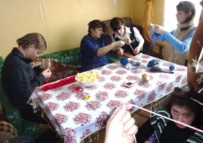
We also planning to keep having fellowship with the young people in a far-away settlement (they are the grads of the orphanage for the children with some mental disability. Now we stay in touch with them via cell-phones. Our last year experience showed how complicated the fellowship with such young people is. Our goal is to speak to them about Christ and to teach them to earn money for living (it is a very big problem in the place located far away from the city). They are trying to crochet slippers. The hand-made slippers are pretty and comfortable. We need your help in selling them. If some Christians from your church could buy some slippers, these girls would be able to earn their living. If you have a desire to help us with it we will find the way to send them to you. I think the sum of $15 would be enough to cover the materials and transmission costs and the rest of the money from sales revenue would be these girls' salary so that they would be able to buy some food and other necessary things.

We would really appreciate your prayers for our Christmas for orphans ministry! This time is special. During this time we can reach about 700 orphans in 8 orphanages of Kursk and the Kursk region. More than two months are left before the light holiday of Christmas and we ask the Lord to provide us with all the necessary finances and technical opportunities to visit all these orphans. Please join us in our prayers!

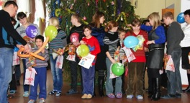
Dear friends, in this very complicated year we are feeling the strength of your prayers, care and support! It gives our team much energy to go further and to be faithful to the Lord serving Him in this orphanage ministry!
May God bless your families and you!
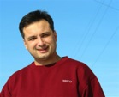
In Him,
Ilya Fadeev,
leader of the Kursk Orphanage Ministry "Alone no More".

