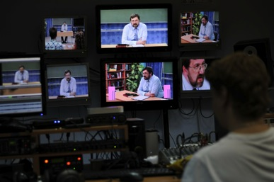
Dear Friends prayer worriers of TVSEMINARY (TVS)!
Very exciting news:
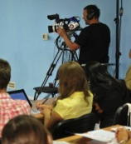
Summer in central Russia was cold so far, June day temperatures are around 70 F, night gets down to 50 F. Cold makes Russians to work faster, so we made great progress this summer in editing and uploading courses on our YouTube Channel and in creating 11 MOODLE versions of courses for the full time students. So, now we have 19 full courses on our YouTube channel:
https://www.youtube.com/user/TVSeminary/playlists

Our current goal is to upload 30 courses to be accessible online for thousands by the end of 2014. We also finished editing several new great courses in English and we already uploaded them on our TVSeminary YouTube channel. Look at the course on “Cross-Cultural Communication” by Drs. Duane and Muriel Elmer:
https://www.youtube.com/watch?v=qQh64ysd7RA&list=PLpf59FMdbS4JtcLDT79l8K5hyKzDiwbFy

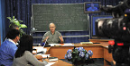
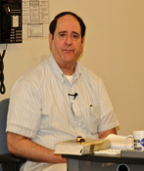
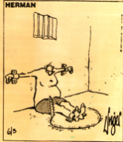
This course, I believe, all people on earth should take! It is not only great for Intercultural communication; it is ‘a must’ for any married couples! Because two worlds, two cultures come together it a marriage and the biggest problem they have it is miss-communication, due to their differences and personal interpretations of the facts. Just watch this course for yourself and you will see how great it is! (You may regret you did not take it before ). We also have this course fully translated into Russian and it is also on our YouTube Channel: https://www.youtube.com/watch?v=Z7mfiCPb2Mw&list=PLpf59FMdbS4K3biqnAih6YoqwVII3_Rnd

Dr. Feinberg on “Inerrancy of the Scripture” is another course available in English and in Russian. It was recorded here in Kursk, Russia, several years ago. Although it has side by side followed translation, you can clearly get it’s English side. Just look at one lecture on “Contradictions in the BIBLE” and you will be impressed with its insights, (of course, if you could understand the logic of it ):
https://www.youtube.com/watch?v=A5nuBNk7i_c&list=PLpf59FMdbS4JuY1Xm6tv7rsiSS0-UqZ8G&index=18

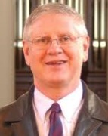
We also finish dubbing over in Russian and editing a full course by Dr. Gram Cole on “Intro to Theology” that we recorded at TEDS. Although it was recorded several years ago and shows less quality comparing to what we have now, you can get great benefit from it’s content! It makes you feel like you are a TEDS student seating in the class:
https://www.youtube.com/watch?v=D9ArtcNSyS8&list=PLpf59FMdbS4KzwJWBKpIU7zuC0D4yDmGv
====================
MOODLE Courses and students’ reviews: As I mentioned above, now we also have 11 new MOODLE courses on our TVS Education website:
http://tvseminary.org/
This TVSEMINARY course serving portal was built only months ago, but we registered over 49 000 visitations by now! Soon we will open English version of this course portal science we already have English-speaking students enrolled in our English courses. Almost every day new students are registering for these courses, one day we had 11 new students registered!
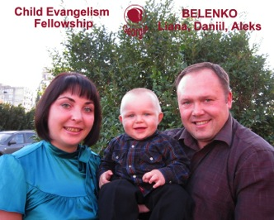
Aleksey Belenko, TVSeminary online student from Georgia:
This Georgia is not an American State , it is an ancient country within Caucasus region, Christianized in IV century. Aleksey and his wife Liana are doing a lot of ministry in Georgia and they feel the need for deeper knowledge. Aleksey was enrolled on Spring 2014, he already finished the full course and passed all exams. Here is his testimony:
“I accepted Christ at the age of 15 through Christians who were affiliated with one church, but I ended up in a church of a different denomination. As in most Baptist churches of those days, there was no Christian counselor in our congregation, who could listen to you thoughts and answer your questions.
As a Russian born in Georgia, I am bilingual, and this helps me in my ministry and in reaching new people for the Kingdom of God. I am now involved with the Child Evangelism Fellowship Ministry. I am married and have a 2-year old son (Daniel). I praise the Lord for saving us – His mercy is great!”
Aleksey's final grade score was 93,56%! It is made up of the scores for the following assignments: the reading report, essay, course paper, weekly quizzes, participation in forum discussions, etc.
Alexey watched the total of 1446 minutes of video lectures, which time-wise means that he basically wanted the whole course twice! YouTube Analytics allows us to track down the number of views as well as the locations where a certain video is played. The Moodle Analytics shows the same numbers.

In addition to watching the video, Aleksey read the course textbook (“The Origin of the Bible”), passed 10 quizzes, wrote 3 essays (200 words), participated in 10 forum discussions, wrote the course paper (1500 words) and passed the final exam. Here is an excerpt from his course paper:
I learned not only about how the Biblical Canon was put together, but also how to share this information with someone who doesn’t have theological or biblical background.
Here is what he wrote in his course evaluation:
I am a church deacon. The course taught me to share the truths and the facts related to the Biblical Canon in a clear way. I will encourage the church to watch these lectures.
May the Lord bless you richly, as you keep doing the ministry so valuable for a Christian's spiritual growth. I wish there were more courses like this!
Aleksey has enrolled for another course!
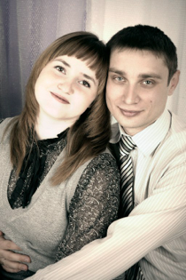
===============
Igor Lependin TVSEMINARY student from Belgorod Russia:
He just finished full online course on “Bibliology” and successfully passed the exam.
Here is what Igor wrote about himself about study with TVSEMINARY:

I’m grateful and praise the Lord for the opportunity to do a systematic study of the Bible as offered by your school. I have been a member of a Baptist church in Belgorod (Russia) since 2005. And the more I walk with the Lord, the more I desire to know Him deeper and grow in my faith. The Bible verse “Whoever wants to be my disciple must deny themselves and take up their cross and follow me» is a guiding principle for me. Christ wants to be our Lord. He calls us to deny the previous lifestyle and take up His light burden. I hope and pray that the acquired knowledge will help me see the greatness of God and realize my need for Him – His mercy and grace – even better.
Igor watched all the course lectures, passed 10 weekly quizzes and the final exam, read the textbook, wrote three essays and the course paper, and participated in all 10 Internet course forums. He scored 94,91% (A category).
In one online discussion the students shared on how their lives changed after the accepted Christ and whether there was someone in their life (like Ananias for Paul) who helped them make the first steps of faith. Here is what Igor wrote:
After I repented of my sins and believed in Christ, my life changed radically. Fear, dependence, melancholy and depression were replaced with joy of the new victorious life and the feeling of freedom. God opened up new ways for me. What had always seemed impossible (like a victory over sin) became a reality in Christ. Living by faith is certainly not easy: you should trust God and His sovereign will, you should take on responsibility for your own life and as well as the lives of your loved ones, you should work hard! Unfortunately, there was no Ananias in my life when I started my walk with Christ. Attending a church doesn’t always guarantee clear guidelines for your spiritual life. A few conversations about the commitment before it is done publicly are not enough. Faith is built when we constantly learn from people who have a profound knowledge and understanding of Scripture. After I gave my life to Christ, I realized a need for good biblical preaching. And this is what I strive for when I teach from the Word of God. I also sing in the church choir.
Now Igor is taking the course on «Bible Study Methods».
=====================
Great potentials for sustaining TVSEMINARY online education in the future:
In May we decided that the first course will be free for the students but all next courses will cost them 30$ for each courses to take in MOODLE. Several students are ready to pay for the next courses. We are working now in developing full educational system of courses in MOODLE that we hope bring some profit. We still give all courses free online on YouTube yet we ask those who want to get credit to pay for each course. And looking on what happen now with new students registering constantly we believe it has good potentials to possibly fully self-sustained ministry in the future.
===================
New Partnerships:
- Latin America. As I mentioned in my last letter In September we are expecting delegation from Latino Educational mission to come to Kursk. They want to establish online DL program in Spanish and really interested in dubbing over our courses that they earlier saw we made in Portuguese.
- Kazakhstan. We also have several new Christian Schools and organizations that approached to us with idea of partnering with our ministry. We just got a new request form Kazakhstan Evangelical School to help them to start online DL program. Moreover, they see what we are doing and they even want to established ongoing branch of TVSEMINARY in Kazakhstan with them helping running our Moodle courses with their students. We prayed for this because our former TVS representative moved from Kazakhstan to Siberia where he continues to be our representative and he is spreading TVSEMINARY courses and represents our school there. Yet, by God’s provision He sent us a replacement for Kazakhstan work now.

- U. S. A. Recently we were contacted by “Third Millennium” ministry located in US
From: Alex Bogat (abogat@thirdmill.org]
Sent: Friday, June 20, 2014 1:32 PM
To: Lois McNeill
Subject: partnership
Hello Lois and Jim.
My name is Alex Bogat.
I am Director of Russian Projects of Third Millennium Ministrieshttp://thirdmill.org
I found Trinity Video Seminary on-line and I think it is amazing what God has been doing through Trinity Video Seminary in Russian speaking world. I checked your page “Scope of Ministry” and realized that TVS and Third Millennium Ministries share the same goals and vision.

I completely agree with you that a distance education has much more advantages over a residential program because it is not an expensive and an unlimited number of students can be enrolled and they can be located anywhere in the world.
Our ministries understand that when you bring national leaders to the US or Europe only 10% of these leaders return to their homeland after completing their studies, robbing Christians in other lands of some of their best leaders. So, we realized that Christian leaders around the world needed to be trained in their own lands. Our mission is to equip church leaders in their own lands by creating a multimedia seminary curriculum in 13 languages…We have many educational resources for anyone that wants them, including online video courses, audio courses, reading materials, recommended assignments, and online testing. This website provides video seminary instruction, audio seminary instruction, audio sermons and lectures, seminary lecture manuscripts, books, magazine articles, an extensive Q&A knowledgebase. DVD, online streaming, radio, TV broadcast —we do it all. We distribute our materials for free. One of our key languages is Russian.
If Trinity Video Seminary is interested in partnership with ThirdMillennium Ministries, please, let me know.

We watched this ministry before, yet, they mostly had only audio courses with PowerPoint presentation and their translation to Russian was not very good. Now they are improved greatly, especially in translations. We may exchange courses and materials with each other especially for our MOODLE students. So, I think we can benefit and bless each other in good way. We can talk more about it at the board time.
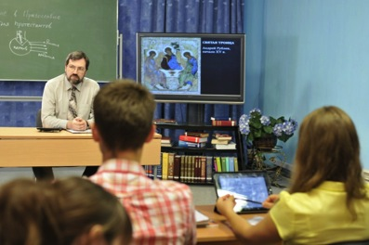
============
Recording NEW COURSE right now at TVSEMINARY:
Course on “INTRO to Russian Orthodox Church for Protestans” by Pavel Togobitsky. We found Pavel in the Siberian Evangelical Seminary in Russia. Pavel is Russian Jew and devoted Evangelical Christian and scholar; he is finishing his PhD studies in one of US seminary.
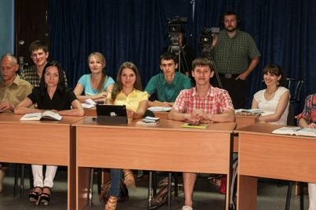
Although this course is in Russian it can be dubbed over into other languages as well. This course in English can be used in many countries and Western Schools since there is a really lack of information about Eastern Orthodox Church there with deep protestant evaluation of it.

And of course this course will greatly benefit all Russian-speaking world and Evangelicals who live and serve in countries with Russian Orthodox dominancy. Yet, even here most protestant leaders know little of this topic and how to share the Gospel with the people who lived in this culture. Here are the hot photos for you right from the class that is going on now:

TVSEMINARY Course on Islam is broadcasted on the TV Station in Siberia:
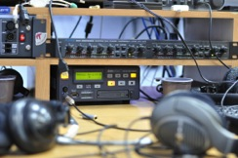
By the God’s power and grace TVSeminary courses are still broadcasted in Siberia to the audience of hundreds of thousands of people. I recently received email from our brother Michael, saying that TVS course on “Islam” by Dr. Shenk that they broadcasting now, is going great and draws much interest of viewers. It is strange, but even some government educational organizations are interested in using it to educate their workers on “Islam” issues. We have many issues brought by millions of immigrants to Russia from Central Asia. Please continue to pray for Michael.
May God bless all of you dear Friends!
We need your prayers a lot!!!!

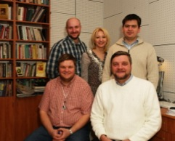
WE THANK YOU SO MUCH FOR YOUR FAITHUL PRAYERS AND SUPPORT!
It is a miracle that we exist and serve,
Because of HIM,

Kursk, Russia
Vitaly Petrov
(edited by Vitaly’s older brother Igor: ‘sorry, can’t stop ‘fixing’ him’)

