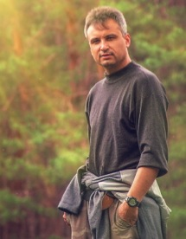
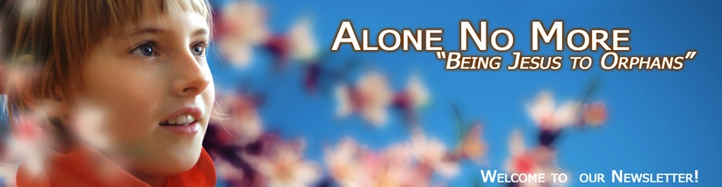
God's love is always felt when someone is in need!
In spite of the economic recession that has its influence upon all the spheres of people's activities our team manages to keep on doing evangelism among the orphans of Kursk and Kursk region. Through this, in the unity and in the consistency of His Church He demonstrates His will, His might and His glory!
At the end of the study year we can give a brief overview of the ministry within this period of time.
The study year in the Flight School of Life is coming to an end! I am grateful to Christ for giving me this great opportunity to be the leader of this Project, to work with tens of wonderful teens the orphans, to share my faith in Jesus Christ with them, to support them spiritually and to inspire them for the full life, filled with meaning of life based on the faith in the Lord!

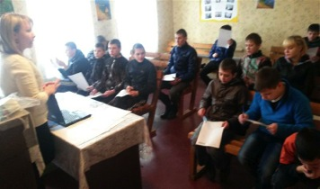
This year was the fourth in the history of this Project, and the Project is unique in its way. Now we have four groups of orphans from three orphanages of the Kursk region. These teens are people with some special needs and problems that often cannot be understood by the people raised in a normal family. And very often these special needs and problems are the reason for the degradation and anonymity of orphans. Our goal is to motivate them for inner development, for faith in God and for work; and we are doing it through the Bible studies.

Our teens passed Bible study exams and as a bonus for the hard work we did a picnic for each group. According to the lists of the students (it was based on the budget) we had 53 students there, but factually we had 67 of them, not taking into account the ones who came to our classes from time to time, not regularly. So totally we had in our classes more than 70 teens. Praise Christ! This is a great achievement; and it inspires us and motivates us for further prayers; it gives us strength and joy!

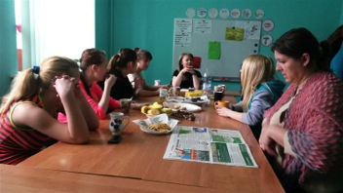
My experience of working with orphans is rather long: it is 16 years; so I trust that there has never been any better opportunity to share the Gospel in a closed institution for children than our Flight School of Life. Some people more than once tried to close the Project. They also tried to change it into just a social project. But the Lord not only broke those attempts, but also made the horizons of this ministry much wider!

This year four young people (the Project grads, three girls and one boy) are going to continue their fellowship with the Lord and with the Christians; they will also participate in some other church projects.



Here are the comments of some Project participants:
- Maxim Kapitanov (the Mokva orphanage). “I like to attend Ilya’s classes. I have learnt a lot of new about Jesus. These are the things I have never heard at my boarding school about. I want to become a businessman and live in Moscow. And I do need the knowledge about the world and about God Who supports me!”



- Nickolay Baryshnikov (the Mokva orphanage): “I am very glad that you have created such an interesting course. It’s not a Geography lesson (the one where I am always napping). I want to keep studying there and have already asked for permission to live at the Training Farm in summer, in the place where some orphanage grads are living. I think the summer will be great”.

- Masha Rodionova ((the Ivanovsky orphanage): “I have always thought that I was very unlucky in life. And now I realize that God loves me; that helps me feel better. I want to have the same fellowship next study year. I am praying”.

- Lena Oktyabrskaya (the Kursk orphanage): “I have found a family. I am very happy with you. And now I cannot imagine any different life. I am not the one I used to be. I love God and I love all of you”.
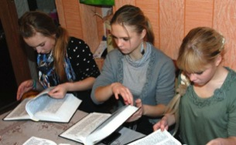
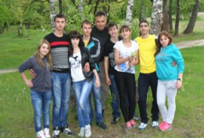
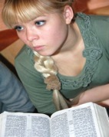
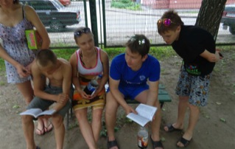
Our God is merciful! God opening the doors for our unique ministry in this fussy and slippery time! States are being broken, the moral foundations of the society are being ruined, and people are suffering from hopelessness… But God’s Word is alive and effectual, and everyone who accepts it gains much inspiration, stability and assurance!

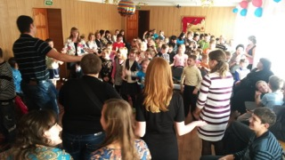
The ones we are ministering to, the orphanage grads are often missing this. We considered them, full-aged people, to be able to live independently, to have some firm moral foundations, some self-service skills and motivation for work…But nothing of the kind! It is incredible, it’s unthinkable, but the guys of 18 after graduating from the orphanage feel burned-out and socially infantile.

Our team keeps on visiting the orphanages. Our fellowship and friendship with the orphans gives us an opportunity to share the Gospel with them on a personal level and that is much more effective than any program. As possible, we give them some gifts and the things they need.

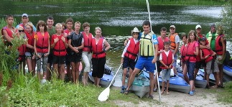
Since June the period of active evangelism starts. We are praying and planning to have three canoe trips and a camp in one orphanage. God wills, we will manage to do it and to have a great time of that special fellowship with the children, of teaching them some Biblical truths and of inspired ministry. Please join us in our prayers and be our co-workers in this very important for the children's lives work!

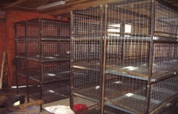
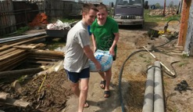
Our post-orphanage supportive Christian “Training Farm” center was built to give these young men a shelter where they could live, work and study. The main goal of the center is to create the conditions necessary for the spiritual and social adaptation of the orphanage graduates. The tutors are working hard to motivate, to inspire and to discipline the guys for studying the Holy Scriptures, to build in them a positive view on themselves and their future, on the society and on the necessity to stop the dependent frame of mind. The principle of the work is very simple: they are living at the farm and work there; some of them also study at some colleges or vocational schools. Their tutors help them organize their time, work out their own budget, they teach them some everyday and working skills and share the Gospel with them. Now there are four orphanage grads who participate in the Project. Two tutors work with them in shifts. They come to the farm as often as possible.
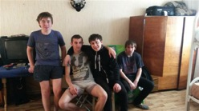
Our main task there now is the interior finishing of the room for the tutor to be able to stay there. We plan him to stay there constantly. We also need to de some interior finishing in some more rooms where some more young guys could live (we would like to have some more participants of the Project). We always have some guys who are eager to join it but we don’t have enough room for it. For the Project to work full we need the tutor to live there on a regular basis. We are praying for it and ask you to pray for it, too, please!
Our second task is to start production. By God’s mercy we have prepare the place where layer hens can live. But now we don’t have any finances to buy those hens. Besides, we cannot have this production until the tutor will live there controlling the production process and the process of the animal care. The “broken” lives of the guys, their negative independent life experience: all this proves that they need some time, some shelter and the wise tutors for their socialization.
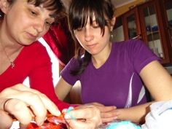
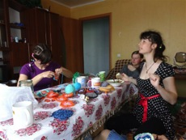
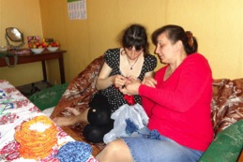
So, now there are four orphanage grads living at the farm. Their names are two Andreys, Russlan and Victor. Though there are very limited in room, we will have to send one more guy to stay there. His name is Nickolay. He is a full orphan. In the nearest future he will not be able to get an apartment or a place in some dorm. That is why the Training farm is the only possible place for him where he could survive through summer. We will give him the necessary clothes, the food and the job. We have a saying: “Squeezed but pleased”. We are praying for this and also ask you to join us in prayer!

We keep on doing our ministry in the village in the middle of nowhere (Kursk region, the settlement of Korenevo). Where some orphanage grads (mostly girls) are living., They are all from the orphanage for special needs children. We managed to motivate them to do knitting to be able to earn some money. The process turned out to be long and complicated. But we are happy to know that the girls are eager to continue doing it. We are praying and hoping that the girls will have some professional skills in it sooner or later. We are also praying for finding the market for selling the things they knit (they make very pretty slippers), both through the internet and among the Christians. These young girls need the Gospel; they need its wisdom and the news about salvation, the news that changes lives. Please pray for our successful evangelism and labor training in that settlement of Korenevo.

From the bottom of our hearts we are grateful to all the co-workers, to all the partners, to all the prayer intercessors and to all the people who could not stay indifferent to these children, whose problems become their problems. I am grateful to all who understand that these problems can be solved only when we join our efforts together, in one spasm of a heart, in common prayer and dedication.
Grace be with you and peace!
Yours in Christ, Ilya Fadeev.

