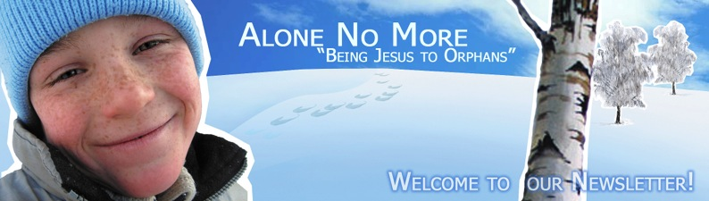
When a baby is born in a family it’s the best gift from the Lord! When God gave the baby Christ to the world it was the most precious gift for the whole mankind!
Unfortunately, most of the “mankind family” did not appreciate this gift of God for one reason. This reason is the sin! For exactly this reason many Russian parents abandon their children leaving them “to the discretion of fortune”, without parents’ love and care. And the Christian team “Alone no more” is ministering to these children trying to restore God’s justice!
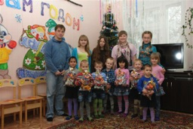
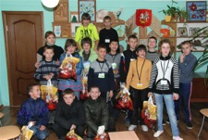
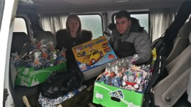
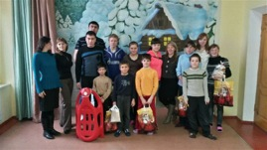
The Christmas holidays are over. We visited 7 orphanages sharing with the children the Good News about the Savior; sharing the spiritual treasures with them trying to make this great Christian holiday meaningful in the eyes of these abandoned by parents children! This year the Lord has blessed us with enough finances for the Christmas gifts, so we managed to get for them some warm clothing and sports equipment plus to traditional toys, candies and soap/toothpaste! Every gift contained some Christian literature. Praise the Lord! We managed to prepare 716 gifts; that was enough for the preschoolers, for schoolchildren, for grads and even for the teachers and the orphanage administration! In some very far away orphanages (the Tyotkinsky orphanage is one of them) we were the only guests who came there with gifts, games and the Christmas drama! Both the children and their teachers appreciated this knowing that we were doing it with all our hearts. As it had been planned we visited the following orphanages: the Ivanovsky, the Mokva, the Pensky, the Tyotkinsky (both preschool and school) and the Tzvetovo. We also reached for the Gornal orphanages children who had been transferred to the other orphanages and also some Kursk and Korenevo orphanage grads. The Christians from five Kursk Evangelical churched participated in the Program; this fellowship and spiritual work draw the team together and were a great blessing for all of us!
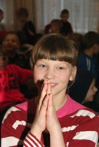
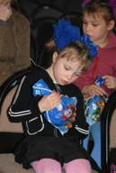
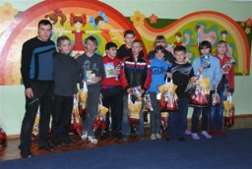

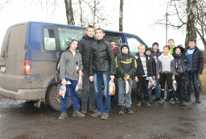
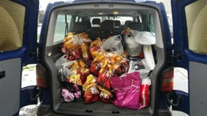
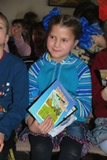
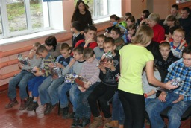
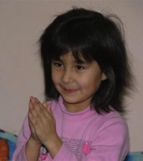
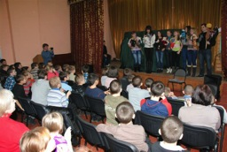
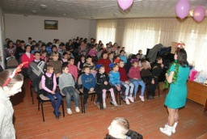
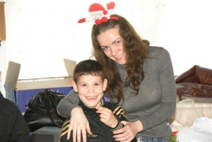
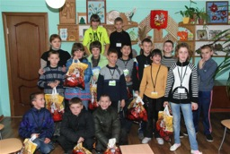
The Lord answered our prayers and blessed us with the van we managed to buy on December the 23rd. so we felt comfortable and warm during our travelling! It was a great mercy given us by the Lord as the best gift for His son’s Birthday! The gift was given through his children! After the leg of route from Germany we needed the van so immediately that we even did not have enough time for cleaning it!
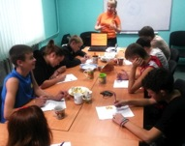
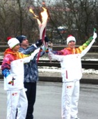
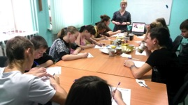
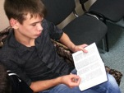
The Christian Flight School of Life Course continues its work since Jan., 2014. It works in the Mokva, the Central and the Ivanovsky orphanages. In the groups of 8-10 teens (the number depends on the orphanage and our conditions) we study the Scriptures, discuss the topics that are very important for these teens, learn to cook and to plan the future. The main task is to demonstrate to them the Love of Christ, to inspire them for their future independent life, to be able to trust God and oneself and to dispel fears of the big world and the independent life! Upon an initiative of the evangelical Christians, with the support and coordination of our team, the best Flight School of Life student Konstantin Borisenko participated in the Olympic Flame run in the city of Kursk! This event in his life is very meaningful both for him and for many other orphans who could witness that this guy, who is one of them, participated in that very important state ceremony together with world famous sportsmen, some outstanding people and statesmen! Praise the Lord for this wonderful opportunity to share the Gospel to the orphans through the Christian Study Course!
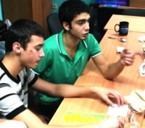
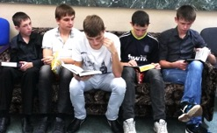
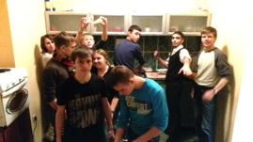
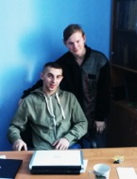
Even the heavy frosts we are having now do not stop us from constructing the cattle sheds and chicken cages at our Training Farm. Now there are two guys living there, they are the Ivanovsky and Gornal orphanages grads. Their names are Russlan and Alexander. They are responsible for keeping the farm in order and for doing some construction works. Thanks to their Christian mentor and the Christian volunteers we are having the fellowship and the basic Christian knowledge studies with them on a regular basis. We are praying for starting the production in spring to be able to gain some profit for both the farm development and the guys’ needs!
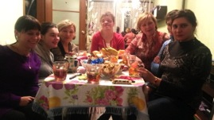
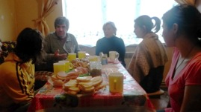
Any job becomes for the orphanage grads “stumbling block». So having talked with some of them (they are a little mentally and psyche disabled) we found out that most of them languish in poverty trying to make both ends meet having only a disability pension of about $120 a month. It should be split for the utilities, food, clothing and transportation. This money is not enough! We can easily understand it seeing their hungry eyes when we bring some food to them! Their settlement (a kind of “orphans’ ghetto” is located in the economically undeveloped backwoods of the Kursk region where it’s a problem to find even a low-paid job. There is a number of such orphans grads’ settlements in the Kursk region. After many prayers and thoughts we made a decision that we should busy those young people (mostly girls) with some physical work that will help them spend their time in the right way and bring some income! We are planning to buy some threads and tools for knitting for them to be able, after a short course of training (most of them can knit), to knit some simple things that can be used in everyday life. We are praying for getting some finances for the input materials and for the trade area for this simple production. Please join us in this prayer! The problem solving will bring the girls some income that is so necessary and, thereafter, enough food, medications and clothing. Now we have decided to visit them in this settlement on a regular basis (it’s located at a distance of about 120 km from Kursk) to have some fellowship with them and to support them as much as our team can afford it!
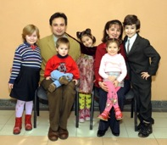
There is a new documentary film about the orphans’ problems in our country Internet (maybe it exists in Russian only). But if You have a chance to watch it with the help of some interpreter I advise you to watch it: it discovers many problems of the orphanhood. These problems are being tried to be hidden by some authorities who are not interested in them to be known by the others. The title of the film is “Bluff, or Happy New Year”.
From the bottom of my heart I am grateful to Christ for all the opportunities of sharing the Gospel and the social support of the orphans He gives us through You, our fellow workers, our dear brothers and sisters! I hope this year will be very fruitful for all of us in the spiritual life and in ministry!
Praying for Your families, Your churches and You,
Ilya Fadeev.

