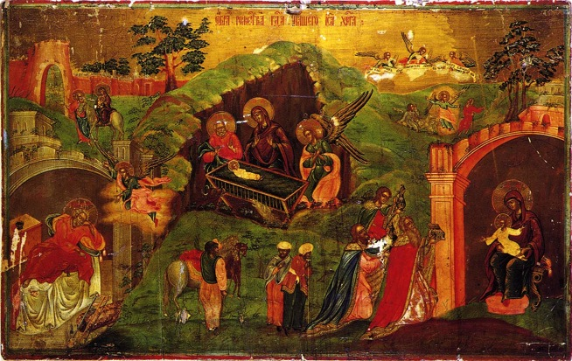
Merry Christmas!
From Igor Petrov family in Russia!

The Savior was born! What a joy we have in Jesus!

It is time to thank our Lord Jesus for all the blessings in 2013
Ministry:
- Protection from powers who were trying to hinder our Christian video course production at TVS this spring (see http://www.russiadistancelearning.com ) Praise the Lord!

- Number of our courses were rearranged and loaded on out YTUBE channel (http://www.youtube.com/user/TVSeminary ) Praise the Lord!

- Over 106 courses and seminars videotped so far, about 70+ were produced, we dubb them into Russian, English, Uzbek, and Portuguese now. Praise the Lord!

- We thank all who supported TVS’ very effective ministry, but the recourses are scarce, please pray!

- Our New Testament Church (where I preach and teach SS) is growing 12% this year! (see http://vk.com/club16325814) We are preparing for big Russian Christmas Eve concert on January,6! Please pray, last year we had over 60 new visitors!

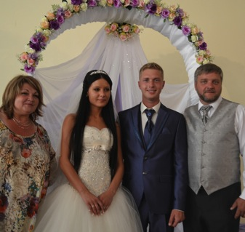
- 6+ summer camps for kids and teens were a great blessing! Over 450 heard the Gospel, many prayed for salvation! Praise the Lord!

- God blesses various ministries in Kursk: Evangelistic outreaches, Orphanage ministry, School of life Piloting for orphans, Prison ministry, Summer camps, and several concert (see reports on www.kurskministries.org)

Petrov Family blessings:
- We all are alive! Our health is more or less in accord with our age .
-Svetlana is busy carrying for us and our nursery and many needy people. She finally has a good winter rest now. Please pray for her health.
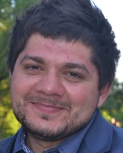
- I (Igor) keep serving as a director of Master Program in TVS, dubbing the courses videotaped in TEDS, as well as teaching, preaching and overseeing various ministries in Kursk and beyond. Praise the Lord!

- Our oldest son Victor got married to Kristina, they live and serve the Lord (summer camps, youth ministry) in Kursk, they expect a baby in May 2014. Praise the Lord! Victor develops his small business: growing and selling fruit and berry plants.

- Our middle son Andy stays with us, works for US internet giftbasket company and develops his rose plants production. He is looking for a good Christian wife. Please pray.

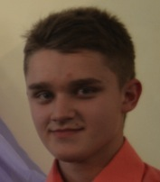
- Our youngest son Cornil is serving in our church as lead singer, he learns to play guitar and writes Christian sons. He is finishing high school in Kursk and plans to live us next year to study in Czech Republic Tech University. We have a big challenge: need to raise $9k for his first year of studies in Czech Republic. If he succeeds, next 4 years will be tuition free. Please Pray.

We all thank you so much for your love, prayers and support! We can't do it without God's blessings through you! May God bless you abundantly!

P.S. If the Lord moves you, pray for s and ministries and send your support for Igor Petrov Kursk Ministries via:
Christ Centered Homes P. O. Box 777 Atlanta, TX 75551
Christ Centered Homes is the non-profit organization, which greatly supports Kursk Ministries. Christ Centered Homes will send you a statement for your taxes.
Grace and Peace!

