

“Be exalted, O God, above the heavens, and let your glory be over all the earth”. These words from Psalm 108 excellently reflect the blessings the Lord is filling the Orphans Ministry “Alone no More” team in Kursk.

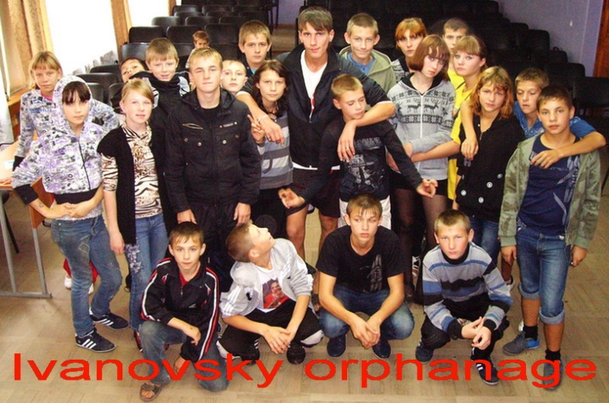
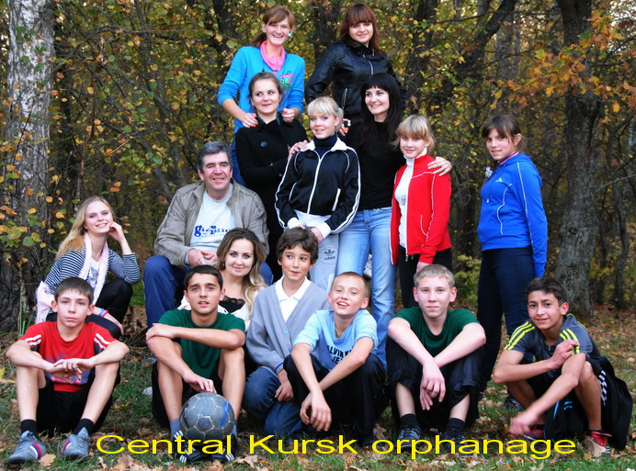
The second month of the new 2012 study year is coming to an end. The three courses of Christian Project “The Flight School of Life” have started successfully. This year we have three groups of orphans who attend the lessons of the course. They are 14 orphans from the Mokva orphanage, 25 orphans from the Ivanovsky orphanage and 12 orphans from the Central Kursk orphanage. Of course, this number of the orphans attending the classes is rather approximate: much more of them are eager to do it. We are constantly trying to find the recourses to invite more of them there.
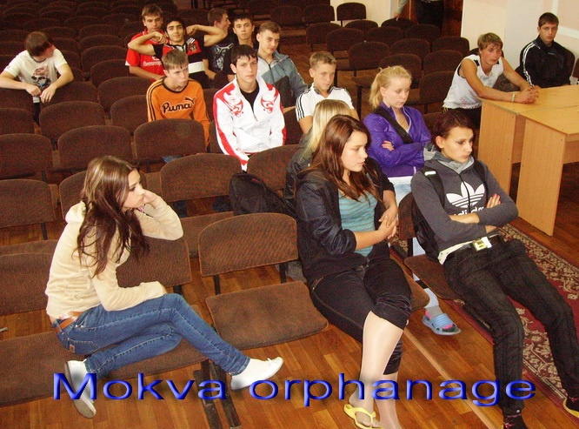
The basis of the Project is spiritual and social adaptation of the orphans to the life after graduation. Most of the orphans got acquainted with Evangelical Christians in the Bible summer and winter camps and in the canoe trips we do every year. The goal of our “The Flight School of Life” Course is to consolidate the rudiments of faith in them, to encourage them to live according to the Christian principles and to work for the achievement of their personhood. The basis on the Course is the Biblical doctrine; besides, the Program also includes some training sets necessary for the full personal enhancement. Along with that the Program includes some practical lessons devoted to the budget planning, conflict management, cooking, work on the character training and on the goals of life formation. The teens are split into 6 groups: it makes the work with each one easier.
We are grateful to you for your support of the Project: during these years (we have been working at it for the 5th year already) we have gained a lot of evidences of its value and necessity. There is no one among those who have studied in this “School” who became alcohol or drugs addicted or got into prison. This fact speaks volumes! Plus to it most of them study or work! And it’s against the background of the very adverse statistics about orphanage graduates! Thanks to the inspiration given by God and thanks to your dedication and self-sacrificingness our team is continuing doing this ministry with great joy!

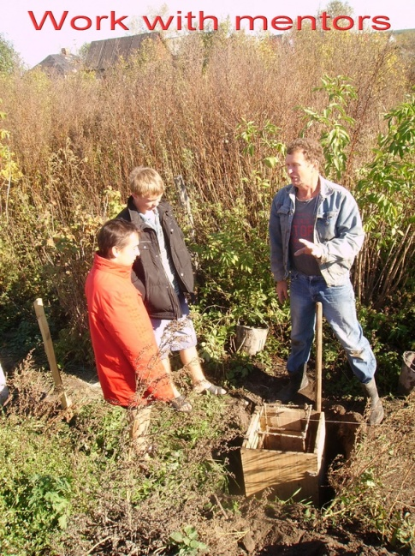
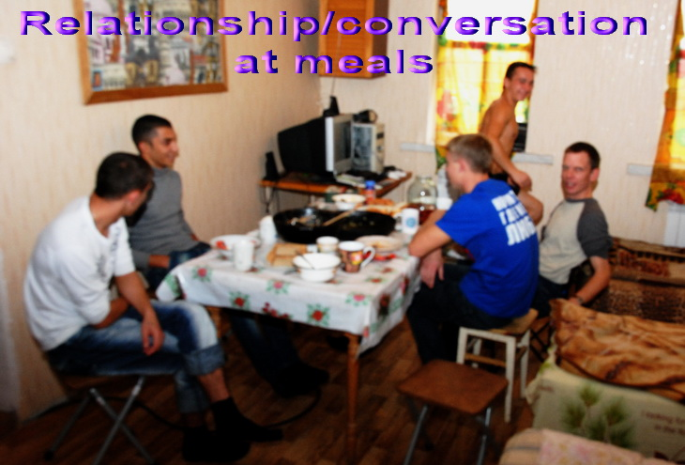
Our special joy before the Lord is the good news that we have from “The Training Farm” Project. The Project was planned for three young men but now we have four of them there. They are the graduates of the Mokva and the Ivanovsky orphanages. They are living there and together with their Christian mentors are doing some construction works. “The Training Farm” Project gives them some responsible life skills, the elements of the construction skills, some Christian education and the fellowship with the people whose lives have already been changed by Christ. Of course the speed of construction is much slower than if it were being done by the professionals but the key is that this is the educational Project and one of the goals of it is to teach the orphans to make something with their own hands, to teach them to think with their own mind and to build their lives basing it on the Christian doctrine.
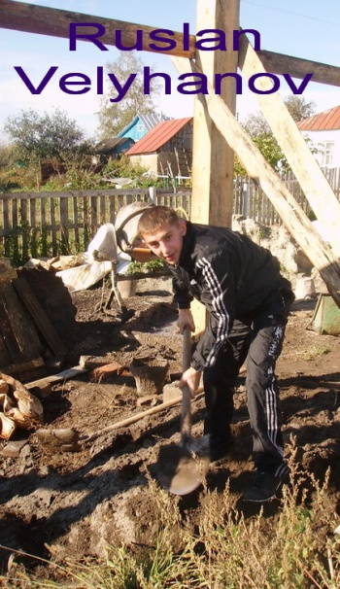
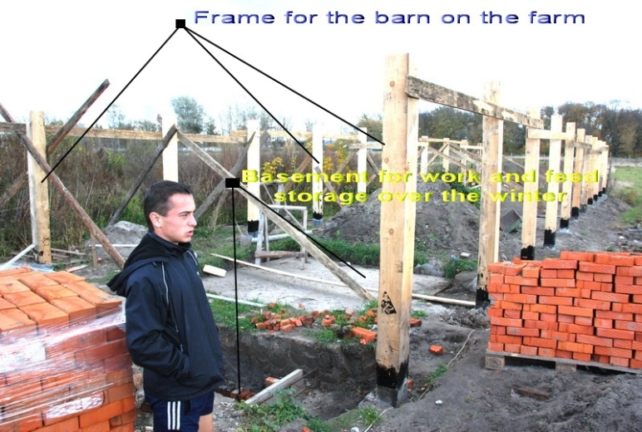
Slava Chaly, Elnur Shafiev, Ruslan Velyuhanov and Yura Malyshevsky are the guys who have always had very few dedicated and loving adults in their lives. Life without parents’ care surely left its imprint in their nature, but praise God did not ruin their kind-heartedness and belief in people. Trying to be independent they make a lot of mistakes and miscounts. We have to teach them to manage a household, to motivate their life position, to be caring for the others and hard-working in work and studies. This Project exists and works thanks to your support. We have enough food for them; we have bought enough boards for the construction works and we have enough finances for the teaching materials. The Christian mentors devote their time to the fellowship with the young guys; they are doing evangelism there with great inspiration. We are praying for the construction works to be completed by the next year and for the first “lodgers” (a horse, some chickens and sheep) to be placed there.

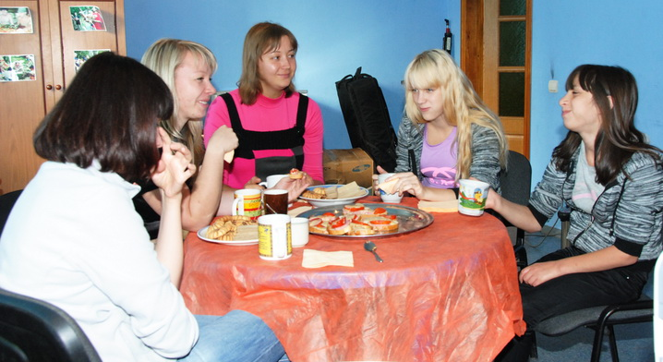
“The Harbor of Kursk“ Project is a social hotel for the orphanage graduates. The goal of the Project is to move a base to the life, the studies and to their spiritual and moral formation. There are some hotels of this kind in the cities of Vladimir, Saint-Petersburg and Ryazan. This year the Project for the girls started in Kursk. Now we are processing the documents that will let the Christian feminine mentors matronize the young girls. Before the papers are ready we are mentoring the girls distantly. The mentors have some instructive meetings with the girls, have some training lessons with them and do some individual work with these grads. Our main goal is to share about Christ, to work at early pregnancy prevention (it’s a big problem, unfortunately) and to inspire the girls to feel the equal citizens of a big country who are able to shape their destiny themselves! Please pray for the development of this ministry in Kursk, for our girls and for their relationships with the Lord and with the people around!

I am grateful to the Lord for your dedication to the Orphans Ministry in Kursk. Your support gives us an opportunity to change something in the life of the orphans who have never seen parents’ love and care. This is not just generosity; this is the deed pleasing to God (James 1:27)! Of course, the economic crisis brought its serious changes into the possibilities of our ministry but I sincerely believe that the Lord is above all these problems!

This month we have got two suggestions from the authorities of the Orphans’ resort and one other Orphanage. They offered to us to do the regular Biblical meetings for the children who come to the Orphan’s resort to have some medical treatment (3,500 children attend it within a year) and to do a Bible summer camp for more than 100 orphans.
This is our prayer request; please join us in this prayer!

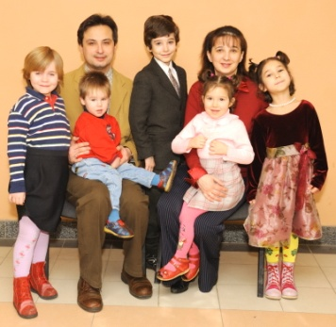
Christ bless you!
In Him,
Ilya Fadeev.
Youth Ministries Leader
Kursk, Russia
Cell: 011 7 920 707 3355 ilfland@yandex.ru

